

Africa Journal of Animal and Biomedical Sciences 6 (1), 2011
ISSN: 1819-4214
©INABSTA

Phytochemical profiling and larvicidal activity of Synadenium grantii (Hook. F.) extracts on Anopheles gambie mosquito larvae

M. P. Njeri¹, H. Matovu¹, I. Nakalembe¹, W. Olaho-Mukani²

¹ Faculty of Veterinary Medicine Makerere University, P.O. Box 7062, Kampala, Uganda, ²Ministry of Agriculture Animal Industry and Fisheries, Directorate of Animal Resources, P.O .Box 513, Entebbe Uganda
Correspondece author: Email: williamolahomukani@gmail.com

Abstract

A study was done to establish the phytochemical profile of Synadenium grantii (Hook. F.) extracts and determine their larvicidal activity on mosquito larvae. Three parts of Synadenium grantii (leaves, stem and roots) were extacted using ethanol and diethyl ether by soaking for 7 days. The phytochemical profiles of the different concentrations of the extracts were determined after filtration. Synadenium grantii was found to contain tannins, reducing sugars, alkaloid salts, anthracenosides, coumarins, flavonosides, steroid glycosides and anthocyanosides. However, the leaf extracts lacked steroid glycosides, while the stem and the root lacked both steroid glycosides and flavonosides. A larvicidal assay of each extract in varying concentrations was evaluated against 10 mosquito larvae in vitro. The larvae were then observed after an exposure period of 24 hours at an interval of 2 hours. The results of the larvicidal assay demonstrated that the ethanol extract from the stem had the strongest larvicidal activity at all the concentrations used of 20%, 8%, 2%, 1% and 0.5% causing a mean death of 86.7%, 90.8%, 85.8%, 85.8% and 84.1%, respectively. The diethyl ether extract from the stem showed the least larvicidal activity with a mean death of 35.8%, 29.2%, 30.0%, 21.7% and 33.3%, respectively. Generally, all the extracts from the different parts of the plant had larvicidal activity to a varying degree. It was further observed, that even for the larvae which did not die, had evidence of larval development inhibition. This study showed that extracts from this plant had phytochemicals which had larvicidal activity on mosquito larvae. The stem ethanol extracts had the most pronounced larvicidal effect on mosquito larvae with nearly 100% mortality at concentrations as low as 0.5% in 6 hrs. This study has showed that this plant has biopesticide effects and its application should be integrated with other mosquito control programmes. However, more work should be carried out on larvicidal efficacy of the active ingredients in the extracts of Synadenium grantii.

Key words: Phytochemical profiling, larvicidal activity, Synadenium grantii, Anopheles gambiae

Introduction

Ecologically, mosquitoes are important components of aquatic and terrestrial food chains as they serve as food for a number of aquatic and terrestrial animals including birds and other insects. With respect to the human and animal well-being, mosquitoes are of great economic importance because their bites are annoying and may cause skin allergies. They are also vectors for a number of diseases causing organisms such as Plasmodium species, yellow fever virus, Dengue fever virus, Rift Valley fever virus and viruses that cause certain types of encephalitis such as West Nile virus (1).

World Health Organisation (WHO), for example, estimates that globally malaria alone is responsible for 247 million human clinical cases and 800,000 deaths annually, the vast majority of cases being (86%) being in sub-Saharan Africa, followed by East Asia (9%) and Eastern Mediterranean regions (3%). It is estimated that more than 40 percent of global population (greater than 2.1 billion people) is at risk of malaria (2)

A number of methods have been used to control malaria transmitting mosquitoes. These megthods include: physical, chemical or biological approaches. Some of these methods have environmental and toxicological effects and therefore their use has been contested. Ideally, vector control methods should be efficacious, environmentally friendly and cost effective. There are plants that have been shown to have larvicidal activities on mosquito larvae and repellent or insecticidal effect on adult mosquitoes. Plants with larvicidal or insecticidal activities include: Synadenium grantii, Pyrethrins, Derris eliptica (Rotenone), Azadirachta indica (Neem), Nicotiana tabacum (tobacco), among many others. Plants with mosquito repelling properties include: eucalyptus, lavender, catnip, peppermint, rosemary, marigold, and citronella grass. Phytochemicals obtained from plants with proven mosquito control potential could be used as an alternative to synthetic insecticides or along with other insecticides in the integrated vector control programmes. Plant products can be used, either as insecticides for killing larvae or adult mosquitoes or as adult mosquito repellents (3).

Synadenium grantii also called African milk bush in English and Kinyunywa in Swahili is a monecious, succulent shrub (5-10 metres high) and a native of East and Central Africa. It has a cylindrical stem varying from green to grey in colour depending on the age and prominent leaf scars on green stems and a copious latex. The milky sap is very corrosive and can cause contact dermatitis in animals and man. All the parts of this plant are considered very poisonous.

Leaf extracts of Synadenium grantii had earlier on been evaluated for their efficacy in reducing the population of the green leafhopper, Nephotettix virescens and its transmission of rice Tungro virus under field conditions (4).. The extract of this plant was shown to reduce the population of the vector significantly in both the nursery and main field. In Tanzania, a decoction of the stem bark or the latex was taken to expel a retained placenta in women, whereas a leaf decoction was drunk as an abortifacient (5).. A root preparation has been used as a malaria remedy and dried root powder was used to treat psychosis (6). The acetone extract of dried latex showed high molluscicidal activity against the freshwater snails Biomphalaria alexandrina and Bulinus truncates (7). It was against the above background that this designed to evaluate larvicidal of this plant against Anopheles gambiae mosquito larvae in vitro.

Material and Methods

The plant samples were collected from Kitante, in Kampala district, Uganda. Analysis was done at the Natural Chemotherapeutic Research Laboratory, in Wandegeya Uganda. All parts of the plant were collected on the same day for uniformity and consistency. The stems and root barks were removed while the plant was still fresh using a knife as this was easier than when the plant was dry. The plant materials were dried in the shade for three weeks to avoid decomposition of the active ingredients. The plant preparations ware protected from sunlight because of the potential for chemical transformations resulting from exposure to ultraviolet radiation. Further drying was done in a hot air oven at 50ºC, just before further processing to remove all the moisture. The plant materials were then ground in a hammer mill to improve the efficiency of extraction.

Each powdered material of different plant parts were extracted by soaking in diethyl ether (non-polar) and 70% ethanol (intermediate polar solvent) for 7days. The extracts were then filtered using cotton wool and then concentrated using a rotary evaporator under vacuum at a temperature of 50ºC. They were then dried in a hot air oven at 50ºC to remove all the water or extraction solvent present. While dry, they were weighed and stored in the refrigerator at -20ºC before the larvicidal assay was done. Reconstitution of the extract in alcohol was done using distilled water while that in diethyl ether was reconstituted using dimethyl sulfoxide (DMSO) since the latter is a highly polar solvent and has a low level of toxicity (8),.

The different parts of Synadenium grantii extracts were analyzed for the phytochemical composition by standard laboratory qualitative methods (9, 10, 11). The extract (1ml) was mixed with few drops of 0.1 % ferric chloride and observed for brownish green coloration which indicates the presence of tannins. To 1ml of the extract, Fehling’s (I+II) (1ml) solutions were added and heated. A brick red precipitate which indicates the presence of reducing sugars. To 1ml of the extract was added a few drops of aqueous solution of hydrochloric acid and 0.5 ml Mayer’s reagent. Formation of yellowish white precipitate indicated the presence of alkaloids.

Four millitres of extract was concentrated to 2mls and 2mls of 25% ammonia were added by shaking. A formation of cherished red colour of the alkaline solution indicated the presence of emodols (aglycones of anthracenosides) in an oxidized form.

The ether extract (5mls) was evaporated to dryness. The residue was dissolved by heating in 1-2mls of water; the aqueous solution was divided into two equal volumes in 2 tubes. To one, tube ammonia solution (1.5mls, 10%) was added, and the other tube served as a reference. A formation of green fluorescence under UV light indicated the presence of coumarins.

To 1ml of the extract was added an equal volume of cold concentrated sulphuric acid. Formation of intense color indicated the presence of glycosides. The extract (5mls) was evaporated to dryness. The residual was dissolved in methanol (50%, 2mls) by heating, then metal magnesium and 5-6 drops of conc. HCl were added. A formation of red colour indicated the presence of flavonosides.

Collection of the larvae was done in the animal house at the Faculty of Veterinary Medicine, Makerere University. The larvae were found in clean stagnant and undisturbed water. Collection was done by scooping a large volume of water using a large wide- mouthed container. After, the early to fourth instar larvae were selected using a dropper and put in a bottle containing clean water. This process was repeated until enough larvae were obtained. The identification of Anopheles gambiae larvae was done mostly by observing the resting position of the larvae with respect to the water surface. The Anopheles gambiae rested parallel to the water surface due to lack of a respiratory siphon and also have a unique white or red stripe on their dorsum (12, 13).
The Synadenium grantii extract assays were performed using guidelines provided by WHO (14). In performing larvicidal assays, the mosquito larvae were first exposed to a wide range of test concentrations and a control to find out the activity range of the materials under test. After determining the mortality of larvae in this wide range of concentrations, a narrower range of 5 concentrations, yielding between 10% and 95% mortality in 24 hour was used.

Extracts of the different plant parts in different extraction solvents were prepared in concentrations of 20%, 8%, 2%, 1% and 0.5%. To prepare 20% concentration, 0.4g of the extract were weighed using a top pan balance in a weighing boat and reconstituted using 1ml of distilled water. This was then added to a test tube containing 1ml of water having 10 larvae in it to make a final volume of 2mls. The same procedure was repeated to make the other concentrations of 8%, 2%, 1% and 0.5% with extract weights of 0.16g, 0.04g, 0.02g, and 0.01g, respectively. Larvae mortality was then observed for 24 hours at a 2 hour interval. The larvae were tested for survival by touching with a needle and disturbing the test tube and if the larva did not move after disturbing and touching, it was counted as dead (15,16, 17,18,19). The Bioassay data was analysed using Graph Pad Prism and R-programs and data was summarized into scatter and box plots.

Results

The results of the qualitative phytochemical analysis were as shown in Table 1. Details of larvicidal activity of leaf, stem and root ethanol extracts Synadenium grantii were as shown inn Fig 1. Larvicidal activity of leaf ethanol extracts showed the highest mortality at a concentration of 20% with a mean death of 8.67±2.96. The stem extract using ethanol was the best with mean deaths being 8.67±3.11, 9.08±2.15, 8.58±3.37, 8.58±3.37 and 8.42±3.70 for concentrations of 20%, 8%, 2%, 1% and 0.5%, respectively. The root extract using ethanol showed that at a concentration of 20%, the mean death was 7.58±3.50 while at a concentration of 8%, the mean death was 5.67±3.47. The rest of the concentrations had a mean death below 50% being 3.08±1.78, 4.0±3.57, and 4.5±4.14 for concentrations of 2%, 1% and 0.5%, respectively.

Details of larvicidal activity of leaf, stem and root diethyl ether (DEE) extracts Synadenium grantii were as shown in Fig 2. In the diethyl ether extract, the leaf at 20%, 8% and 2% had a mean death of 9.83±0.58, 9.50±1.24 and 5.17±1.85 respectively. At concentrations of 1% and 0.5% the mean deaths were below 50% being 3.50±3.08 and 3.08±2.02 respectively. With the stem extract, all the concentrations had a mean death below 50%. Concentrations at 20%, 8%, 2%, 1% and 0.5% showed a mean death of 3.58±1.92, 2.92±1.51, 3.0±1.81, 2.17±1.11 and 3.33±1.56, respectively. In the root only the 20% concentration had a mean death (5.50±0.79) above 50% . The rest of the concentrations at 8%, 2%, 1% and 0.5% had a mean death of 3.33±0.49, 4.33±1.15, 4.5±2.15 and 3.5±4.14, respectively. Time taken by the different parts of Synadenium grantii to kill the larvae were as shown in Fig. 3. The comparison of mean deaths of ethanol extraction solvent (6.0) with the diethyl ether extraction (4.0) solvent were as shown in Fig. 4

Leaf
Stem 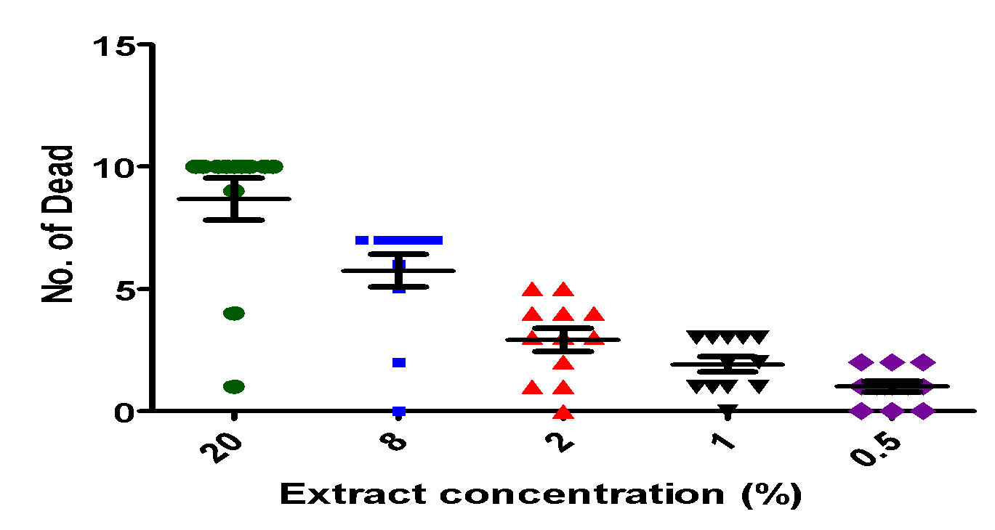
Root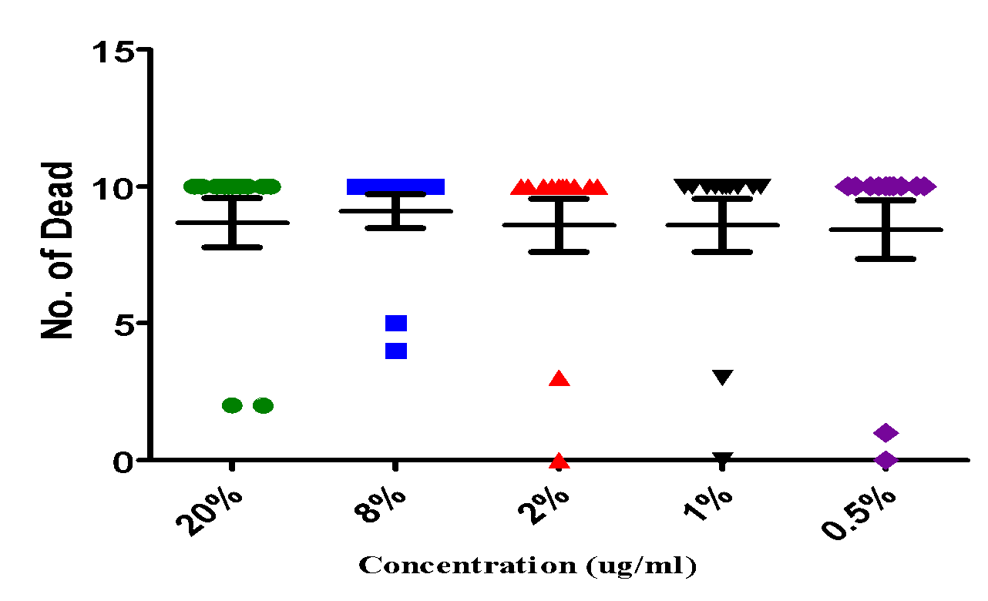
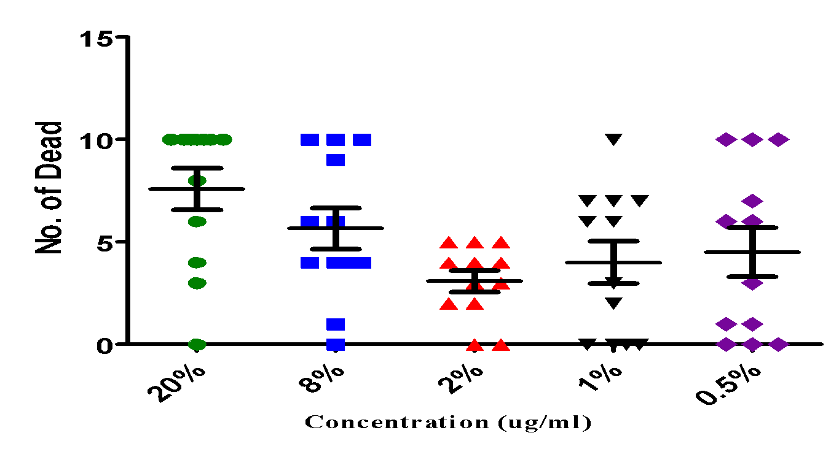
Fig. 1. Moquito larvae mortality dose-response for leaf, stem and root extracted from alcohol

Leaf
Stem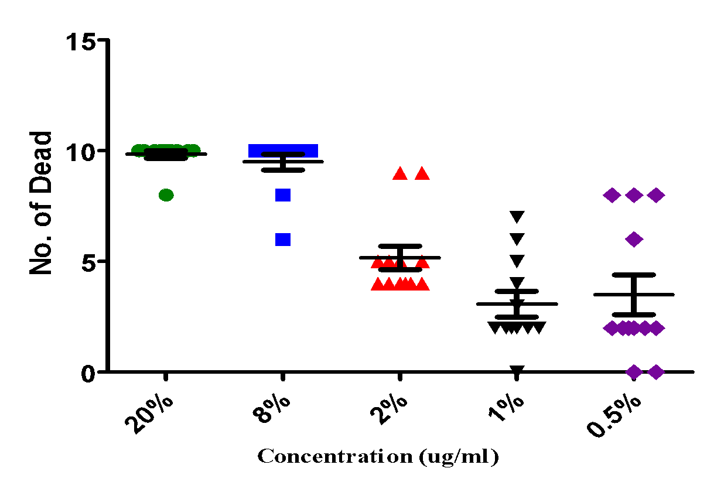
Root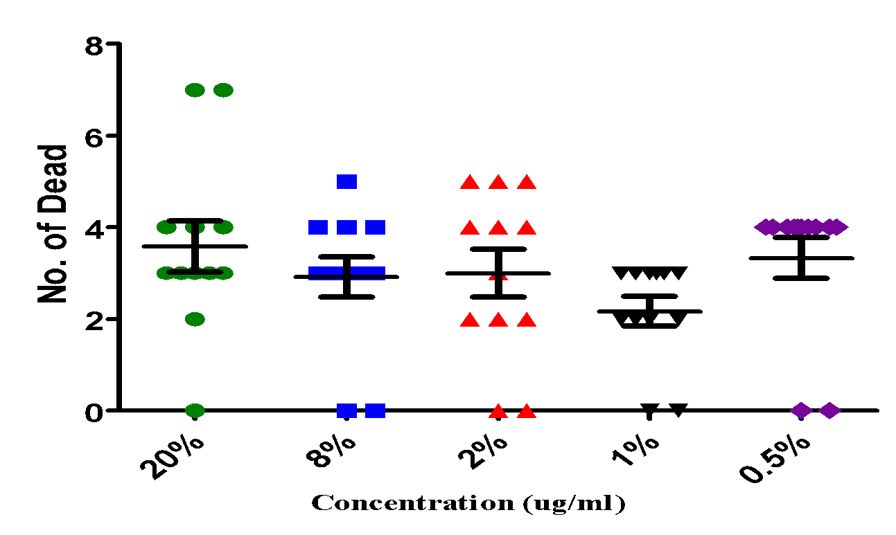
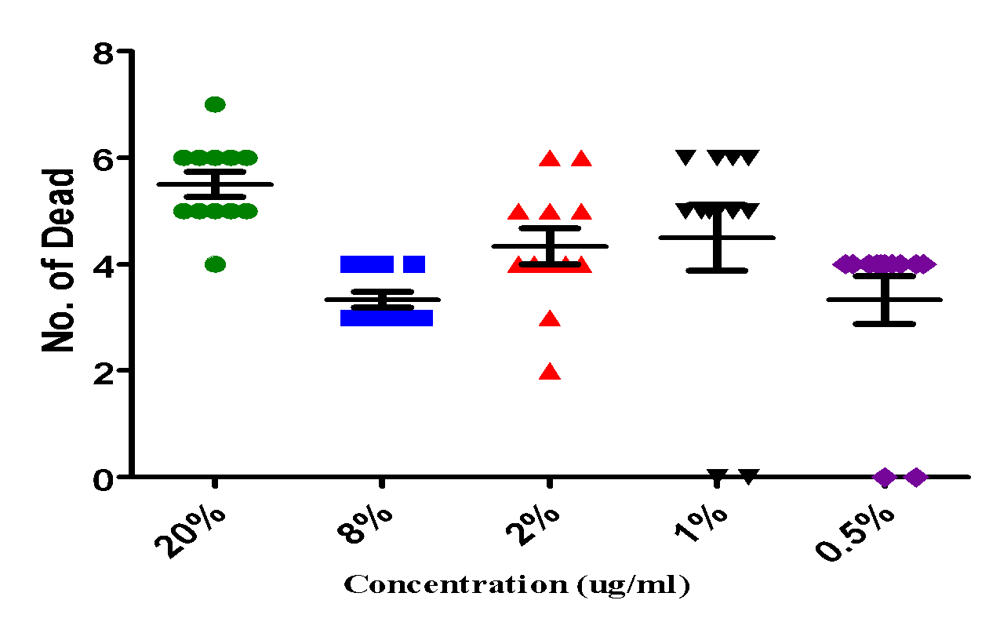
Fig 2. Mosquito larva mortality dose-response for leaf, stem and root extracted using DDE

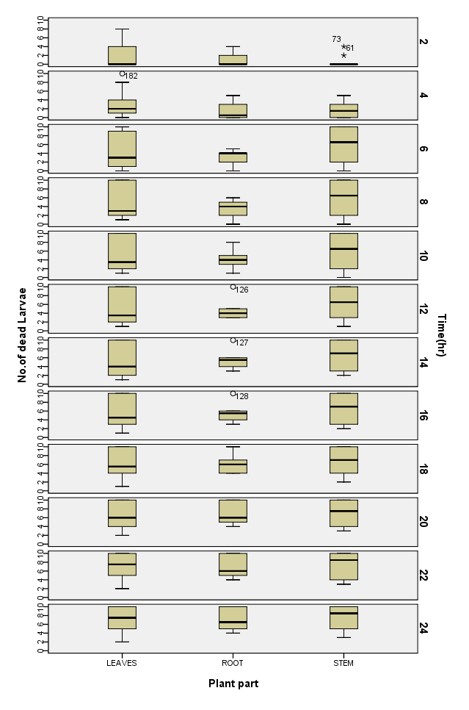
Figure 3. Mosquito larva mortality exhibited by different plant parts with time

Table 1: Phytochemical profile of different plant parts of Synadenium grantii

Phytochemical components | Leaves | Stem | Roots
Tannins | ++ | +++ | +
Reducing sugars | + | ++ | +
Alkaloid salts | +++ | ++ | +
Anthracenosides | + | ++ | ++
Coumarins | + | ++ | ++
Flavonosides | + | - | -
Steroid glycosides | - | + | -
Anthocyanosides | + | ++ | +
+ = Present, - = Absent
+=weak, ++=strong, +++= very strong

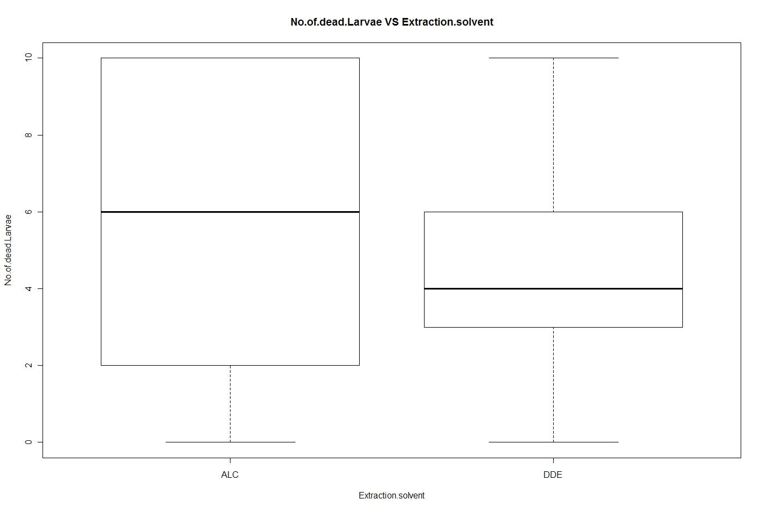

Figure 4: Comparing the performance of the alcohol extract with that of DE.

Discussion

The results of the qualitative phytochemical analysis revealed that all the parts of the plant contained tannins, reducing sugars, alkaloid salts, anthracenosides, coumarins, flavonosides, steroid glycosides and anthocyanosides. However, the leaves were lacking steroid glycosides. The stem was lacking flavonosides. The roots were lacking both flavonosides and steroid glycosides as shown in Table 1.

The problem of high cost and development of resistance by mosquitoes to current synthetic insecticides have revived interest in exploring the pest control potentials of plant(20). Economic and environmental concerns have encouraged use of “soft” pesticides (21). The assessment of the three parts of Synadenium grantii showed that all the extracts had a larvicidal activity against the mosquito larvae with the ethanol extract of the stem being the most effective for the control of A. gambiae larvae with mean mortality deaths at 20%, 8%, 2%, 1%, and 0.5% concentrations being 87.7%, 90.8%, 85.8%, 85.8% and 84.1% , respectively.

The diethyl ether extract of the stem was the least effective with the mean mortality at 20%, 8%, 2%, 1% and 0.5% concentrations being 35.8%, 29.2%, 30%, 21.7% and 33.3%, respectively.
The box plots (Fig. 3) showed that with increased time of exposure, mortality of the larvae increases. In the leaf extract, exposure between 16-18 hours showed 50% mortality and with increased exposure time up to 24 hours, the mortality increased up to 80%. With the root extract, exposure between 14-16 hours showed 50% mortality with the mortality increasing to 70% at 24 hours while for the stem, exposure time at 6 hours gave a mean mortality above 50%, and exposure at 24 hours gave a mean mortality of 90%.

The differences in mortality of mosiquitoes larvae with the same plant parts using different extracts could be due to the ethanol extract being a better solvent for the active larvicidal phytochemical components of the plant. This study has therefore shown evidence that Synadenium grantii extracts were potential biopesticides and corroborates the findings and observations of earlier studies ( 4, 5, 6, 7, 15, 17). This important finding could be utilized in integrated mosquito control programmes. However, further investigation should be done on the efficacy and environmental toxicology on wider and long use effects of application of the extracts of Synadenium grantii.

Acknowledgement

We thank Dr. Grace Nambatya, Director Natural Chemotherapeutic Research Laboratory, in Wandegeya Uganda and the laboratory staff, for all their technical and material assistance.

References

1. Service, M.W. 1993. Mosquitoes (Culicidae). In: Lane, R.P., Crosskey, R.W. (Eds.), Medical Insects and Arachnids. Chapmandon, 196–208.
2. Maru, A., Richard,C., Ryan, W. 2008.World Malaria Report 2008
3. Curtis, C.F., Lines, J.D., Ijumba. J., Callaghan, A., Hill, N., Karimzad, M.A. 1987. The relative efficacy of repellents against mosquito vectors of disease. Med Vet Entomol;1:109–119.
4. Rajappan, K. C. Ushamalini, N. Subramanian, V. Narasimhan, A.A. Kareem, 2000. Effect of Botanicals on the population dynamics of Nephotettix virescens, Rice Tungro disease incidence and yield of rice. Phytoparasitica, 28:1-5
5. Mainen, J., Moshi, Z., Mbwambo, H., Ramadhani, S.O., Nondo, P., Masimba, J., Kamuhambwa, A., Kapingu, J., Thomas, P., Marco, R. 2006. Evaluation of ethnomedical claims and brine shrimp toxicity of some plants used in Tanzania as traditional medicines. African Journal of Traditional, Complementary and Alternative Medicines, 3(3): 48-58.
6. Minja, M.M.J. 1998. The Maasai’s role in the conservation of eco-systems through widespread practice of ethnoveterinary medicine. Paper presented at pastoralists’ NGOs. Report of workshop organised by the Journalists Environmental Association of Tanzania 7. Fayez, A. B. 2009. Use of some plant extracts to control Biomphalaria alexandrina snails with emphasis on some biological effects. Pesticide Biochemistry and Physiology. 95: 159–165.
8. Runa, D. 2003. Pharmacological uses of dimethylsulphoxide. In: Research on the medical uses of dimethylsulphoxide pp 34.
9. Kokate, C.K. 1999. Practical pharmacognosy, 4th Edn. pp107.
10. Harbone, J.B. 1973. Phytochemical Methods: A guide to modern techniques of plant analysis, pp 278.
11. Mariniova, D., Ribarova, F., Atanassova, M. 2005. Total phenolics and totalflavonoids in Bulgarian fruits and vegetables. Journal of the University of Chemical Technology and Metallurgy, 40(3): 255 – 260.
12. French, W. L., Kitzmiller, J.B. 1964. Linkage groups in Anopheles quadrimaculatus. Mosquito. News, 24:32-39.
13. Mason, G.F. 1967. Genetic studies on mutations in species A and B of the Anopheles gambiae complex. Genet Res, Camb, 10:205-217.
14. World Health Organization, 2005. Guidelines for laboratory and field testing of mosquito larvicides, pp 10-11.
15. Abdul, R., Geetha, G., Venkatesan, P., Kannappan, G. 2008 Larvicidal activity of some Euphorbiaceae plant extracts against Aedes aegypti and Culex quinquefasciatus (Diptera: Culicidae). Parasitol Res., 102: 867-873.
16. Bishnu, C., Zeev, W. 2005. Larvicidal effects of aqueous extracts of Balanites aegyptiaca (desert date) against the larvae of Culex pipiens mosquitoes. Afr. J. Biotechnol., 4(11): 1351-1354.
17. Das, N.G., Goswami, D., Rabha, B. 2007. Preliminary evaluation of mosquito larvicidal efficacy of plant extracts. J. Vector Borne Dis., 44: 145-148
18. Badruddoza, D.,2008. Larvicidal Activities of Aqueous Extracts of Nineteen Indian Plants against two Mosquito Species, Aedes albopictus and Culex quinquefasciatus. 535012.html.
19. Nandita, C., Anupam G., Goutam, C. 2008. Mosquito larvicidal activities of Solanum villosum berry extract against the dengue vector Stegomyia aegypti. BMC Complem. Altern. Med., 8: 10.
20. Grainge M., Ahmed, S. 1988. Handbook of plants with pest control properties. John Wiley and Sons, New York. pp 41.
21. Awad,O.M. 2003. Operational use of neem oil as an alternative Anopheline larvicide. WHO Health Journal 24.

