
Factors leading to low grading of goatskins in selected abattoirs, stores and a tannery in Uganda

Africa Journal of Animal and Biomedical Sciences 6(1), 2011
ISSN: 1819-4214
©INABSTA

J. B. Okuni ¹., O. Bwangamoi², L. Ojok ¹.

- Department of Veterinary Pathology, Makerere University
P.O. Box 7062, Kampala.
Email: jbok@vetmed.mak.ac.ug

- Institute for Research and Graduate studies, Gulu University.

Abstract

Poor quality of hides and skins is one of the reasons why Africa partakes only less than 1% of the total value of the hides and skin trade. A study was carried out to determine the different types of skin conditions and other defects leading to low quality of goatskins from Uganda. One thousand six hundred ninety seven goats (1697) from two abattoirs; two hundred seventy seven skin rejects from skin stores and fifty wet-blue skin rejects were used in the study. Two hundred thirty two goats (13.6%) of the goats had skin lesions. The major lesions were: demodectic mange (29.3%), arthropod induced dermatitis (8.6%), abscesses (5.2%), tumours (5.2%), traumatic injuries (4.3%), pustular dermatitis (16.8%), pyogranulomas (3.9%), epidermal cysts (3.9%), parasitic and foreign body granulomas (1.3% each) and ringworms (1.3%). Defects found to cause rejection of skins in the 3 Hides and Skins Stores were: flay cuts (41.5%), putrefaction (39.7%), vermin damage (13.7%), thinness (10.1%), small sized skins (6.5%), dermatophilosis (1.0%) and abscesses (1.4%). The main causes of rejection in wet-blue skins were: putrefaction (62.0%), vermin damage (38%) and flay cuts (18%). Post slaughter defects were responsible for 86.2% of the total rejection of goatskins, while pre-slaughter defects were found in only 13.6% of the goats examined at the abattoir. The overall rejection of skins due to skin diseases was less than 10%. It was recommendeds and that farmers and hides and skin handlers should adopt proper suggested best practices for production of good quality skins; and provisions of incentives as the most important step to improve quality of goatskins in the country.

Key words: Goat skin lesions, skin rejection, abattoirs, hide and skin stores, tannery, Uganda

Introduction

Hides and skins are the most important by-product of meat production in world trade of livestock commodities. Africa alone has 14.7% of the world livestock population but unfortunately, it only partakes of less than 1% of the monetary value accruing from global hides and skin trade (1). Skin diseases and other defects have been cited as the cause of poor hides and skins in Africa, Uganda inclusive (2, 3, 4).

Various estimates indicate that 60 – 80% of goat skins from rural areas of Uganda are lost due to flay damage (5,6). In 2001/2002 financial year alone 50-80% of hides and skins from rural areas of Uganda were rejected due to poor flaying and putrefaction (5). However, this finding contradicts the figure given by the Uganda Leather and Allied Industries Association (Unpublished survey), which puts the rate of rejection due to all factors combined to be between 10 – 15%. These sources do not provide information on the magnitude of rejection due to diseases and physical defects. Further more, it was not clear which particular diseases caused the most rejection. Lesions due to tick bites had commonly been reported to be among the leading causes of ante-mortem defects in goat skins but its real magnitude had not been estimated (5,6,7). A study carried out over three decades ago by Bwangamoi found demodectic mange to have high prevalence in all the three East African countries and alone accounted for up to 41% of the total skin rejection (2). The importance of this disease has not been given in recent reports. In the study just cited above (2), besnoitiosis was found to be present in skins from Kenya at a prevalence of 0.5% in 1969. By 1999, caprine besnoitiosis was found in five provinces in Kenya with the highest prevalence of 36% in Mandera area (8). In this study particular interest was made to determine if besnoitiosis was also one of causes of skin lesions in goats in Uganda. This was after the disease was diagnosed in five goats which had been imported from Kenya (9).

It has been reported that there was a rising trend in the prevalence of sarcoptic mange in goats in Ethiopia (3) and there had been an outbreak in Tanzania (10). In a study by Yibralem in Ethiopia (4), defects due to ectoparasites were found in more than 50% of goat skins and was partly blamed for the decline of grade I – III wet-blue skins from 60 – 70% to as low as 10 – 20% between 1997 and 1998. The situation in Uganda has been unknown.

Since the government of Uganda had embarked on the Plan for the Modernization of Agriculture, it was vital to improve the quality of hides and skins produced as well. Before that can be done, it was necessary to know the current level of disease burdens and the proportion of skin rejection caused by non disease defects especially post slaughter defects. The purpose of the study therefore was to investigate the causes of poor quality in goatskins so that mitigation measures can be instituted resulting in production of high quality goat skins.

Materials and Methods

Two abattoirs located in the centre of Kampala, namely Kampala Meat Packers and City abattoirs were chosen for the study. These abattoirs received animals from all parts of the country. A total of 1697 goats were examined ante-mortem for skin lesions and their conjuctiva examined for cysts of Besnoitia (11) between October 2002 and April 2003. After slaughter the skins of the animals were examined from the flesh side for lesions not detectable ante-mortem. Tissue samples were taken and preserved in 10% formal saline. The descriptions of lesions and tentative diagnosis were recorded with information on age, sex and breed of the goats. The formalin fixed tissues were then processed and stained with Haematoxylin and Eosin for microscopic examination. Some tissues were stained with periodic acid Schiff’s reaction (PAS), Ziehl- Neelsen acid fast stain and Giemsa. Direct microscopic examination on skin material prepared with a solution of potassium hydroxide (KOH) was also done. The information from gross and microscopic examinations was used to characterize the lesions observed. Pathological diagnosis of some specimens was made by applying pattern analysis (12).

A random sampling of every 10th skin rejected was made in 3 selected hides and skins centres in Kampala, totaling to 277 rejects. The causes of rejection were determined through close inspection. Skin samples and scrapings were taken in some cases. Of the total 277 skin rejects, 157 were dry non- salted and 120 were wet salted. To estimate the proportion of skins that were rejected one hundred deliveries to one of the hides and skin stores (SWT Tanners) were sampled from a total of 1200 deliveries in 2 months. The number of goatskins brought in, the number of grade I – III skins and grades IV and V skins were recorded.

Causes of rejection in wet-blue skins were determined by examining every 20th rejection among 2000 skin rejects in survey carried out at a tannery in Masaka. A total of 50 wet blue skin rejects were sampled and the cause of rejection was determined.

Descriptive statistics were obtained for the abattoir study and hides and skins stores and tannery surveys. A Chi square test was performed to compare the magnitude of proportion of certain post slaughter defects in dry non salted and wet blue skins

Results

Skin lesions were found in 232 of the 1697 (13.6%) goats examined. The details and prevalence of skin lesions among 232 skins with lesions were as shown in Table 1. Pustular epidermitis, which was the second most frequent lesion, consisted of four categories: 1) Localized and circumscribed lesions which had matting of hair; 2) Irregular and diffuse lesions which had matting of hair; 3) Nodular alopecic lesions affecting ears, the back of the neck and muzzles; 4) Nodular proliferative and sometimes confluent lesions affecting the commissures of the mouth, lips, muzzles and some lightly haired areas such as axilla, perineum and ventral abdomen. Histologically, these lesions were characterized by large numbers of bacteria, neutrophils, scale crusts (see Figure 1) and in many cases orthokeratotic hyperkertosis. Others had epidermal spongiosis and vessiculations. No aetiological agent could be demonstrated hence it was considered proper to refer to them as pustular epidermtis.

Parasitic granulomas were seen in 3 skins. One remarkable one consisted of 3 elliptical palpable nodules approximately15mm by 10mm on the lateral epigastric region of the left side of the body of a one year old male goat. The histological examination revealed the presence of a metazoan parasite possessing a cuticle and spines and a number of appendages. It was encapsulated in a fibrous tissue with a number of neutrophils and macrophages in those foci where the parasite was degenerating (see Figure 2).

Based on the variation of severity and need to predict the probable effect on grading, infestation with demodex was characterized as mild, moderate, severe and very severe. Details on prevalence of a ceratin degree of severity of infestation with demodex was as shown in Table 2. There was no skin with lesions of besnoitiosis found. Prevalence of conditions found to cause rejection in goatskins in 3 Hides and Skins Stores studied as shoiwn in Table 3. The percentage of skins rejected due to putrefaction, vermin damage, thinness differed significantly (P < 0.001) in wet salted skins and dry non salted skins as shown in Table 3.

The combined effects of post-slaughter defects, namely: putrefaction, flay cuts and vermin damage was found to cause 86.2% of the total rejection in goatskins from the 3 stores (Table 4). The causes of rejection in the tannery in Masaka were demodex (6%), vermin damage (36%), ectoparasites (8%), flay cuts (18%), putrefaction (62%) and others (2%).

Grade I – III skins, which were regarded as good skins, were 87%; grade IV were 6% and grade V,7%; in a total of 9202 skins in 100 deliveries. Grade IV and V were regarded as rejects, making the total percentage of skin rejects to be 13%.

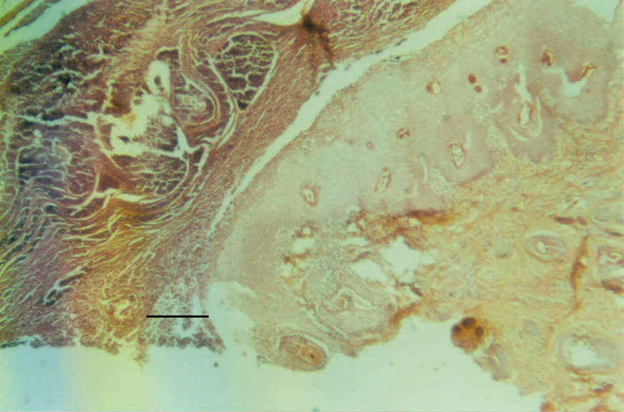
Figure 1: A histological section of a nodular alopecic dermatitis showing pustular dermatitis with epidermal hyperplasia. Bar = 500μM.

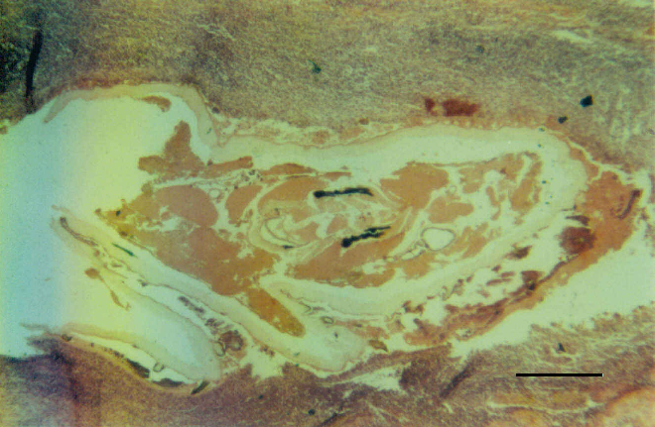
Figure 2: A histological section through an unidentified parasite in the skin with massive infiltration of inflammatory cells around it. Bar = 500μM.

Table 1. Lesions and conditions found in goat skins at the abattoir
Pathological diagnosis | No. of affected animals | % of the affected animals (n=232) | % prevalence  (n = 1697)
Demodex caprae  Pustular epidermitis | 68 | 29.3 | 4.0
Demodex caprae  Pustular epidermitis | 34 | 14.6 | 2.0
Arthropod induced dermatitis | 20 | 8.6 | 1.1
Abcesses | 12 | 5.2 | 0.7
Acanthosis and hyperkeratois | 10 | 4.3 | 0.6
Traumatic injuries | 10 | 4.3 | 0.6
Pyogranulomas | 9 | 3.9 | 0.5
Tumours | 12 | 5.2 | 0.7
Epidermal cysts | 9 | 3.9 | 0.5
Haemorrhages | 7 | 3.0 | 0.4
Alopecia | 7 | 3.0 | 0.4
Scars | 6 | 2.5 | 0.4
Exudative dermatitis | 5 | 2.1 | 0.3
Foreign body granulomas | 3 | 1.3 | 0.2
Parasitic granulomas | 3 | 1.3 | 0.2
Ringworm | 3 | 1.3 | 0.2
Parchyderma and scleroderma | 2 | 0.8 | 0.1
Lymphoid hyperplasia | 1 | 0.4 | 0.05
Others | 15 | 6.5 | 0.9

Table 2. Score of the severity of Demodex caprae infestation among goats examined at the abattoirs.

Degree of severity | Number | Percentage
Mild + | 26 | 40.6
Moderate‡ | 15 | 23.4
Severe * | 19 | 29.7
Very severe ** | 4 | 6.3
TOTAL | 64 | 100

+ : < 10 nodules limited to the limbs
‡: 10 – 30 nodules mostly on limbs but few in the trunk
* : > 30 nodules spread around the body mostly in the trunk
**: Nodules were diffusely packed in all parts of the body.

Table 3. Causes of rejection in goatskins at the hinds and skins stores

Defect Number of skins affected  Dry non salted Wet salted Total |  |  |  | Percentage  (n = 277)
Demodex | 15 | 3 | 18 | 6.5
Dermatophilosis | 3 | - | 3 | 1.0
Ringworm | 2 | 2 | 4 | 1,4
Abscesses | 4 | - | 4 | 1.4
Sarcoptic mange | - | 2 | 2 | 0.7
Putrefaction | 19 | 91 | 110 | 39.7
Flay cuts | 82 | 33 | 115 | 41.5
Vermin damage | 38 | - | 38 | 13.7
Thinness | 28 | - | 28 | 10.1
Small sizes | 13 | 5 | 18 | 6.5

Table 4. Analysis of skin rejection due to putrefaction, flay cuts and weevil damage in wet salted and dry non salted skins
Reason for rejection | No. of affected Skins | % of the total 277
Putrefaction only | 96 | 34.6
Flay cuts only | 94 | 33.9
Vermin damage only | 27 | 9.7
Putrefaction + Flay cuts | 1 | 0.4
Putrefaction + Vermin damage | 12 | 4.3
Flay cuts + Vermin damage | 8 | 2.9
Combination of all the three | 1 | 0.4
TOTALS | 239 | 86.2

Discussion

The study was intended to evaluate the problems posed by certain infectious diseases such as mange, goatpox, contagious ecthyma, dermatophilosis, besnoitiosis and others. The study made discrete search for besnoitiosis in the goats examined but did not find any to be infected. Previous studies (Ojok, personal communication), carried out to investigate the presence of Besnoitiosis in goats in Uganda also did not find any case of besnoitisis. It was therefore concluded that besnoitiosis does not exist in Uganda; but care should be taken wherever imports of goats were made especially from Kenya where the disease was present (8).

The low prevalence of mange and other infectious diseases in both fresh and cured skins and the absence of others like goat pox, contagious ecthyma might indicated a very low prevalence or it could be affected by the timing of the study. But for the case of goats brought to the abattoir, the most plausible explanation was that only apparently healthy goats reach the City Abattoir. Therefore, a farm based cross sectional study need to be undertaken to verify this findings.

A previous study by Bwangamoi (2) had highlighted the problem of demodectic mange which was causing 48% of the damage but flay damage was very low and there was no record of putrefaction. In Kenya and Ethiopia, figures for demodicosis was comparable to those reported here in Uganda. Flay damage was responsible for about 35% of the damages. This implied that skills in flaying need to be imparted to personel doing this job. Im most cases in rural areas flaying was done by any ordinary person. Losses due to putrefaction found in this study was very low with an average of 2.1% in the East African region. In that study only 46 skins from Uganda were examined. In the present study, the percentage of goats which skin lesions as observed in abattoirs is comparatively low (13.6%) and the proportion of rejects from hides and skin centres was only 13% compared to about 63.4% in the study by Bwangamoi in 1969 (2). While the prevalence of demodicosis appeared low (4%), it still ranked high among other skin diseases. Table 2 shows a score of the severity of demodex infestation in the affected goats. The lesions described as moderate, severe and very severe were found in almost 60% of the infected goats. The percentage of putrefaction and flay damage recorded (39.7% and 41.5%, respectively) is much higher compared to the recent study in Ethiopia (4) which recorded 20% and 15% for putrefaction and flay damage respectively.

Skins which were wet salted had greater frequency of putrefaction compared to those which were dry salted. At the same time, dry non salted skins had greater frequency of vermin damage compared to wet salted ones. These findings were similar to that of Yibralem (4) in Ethiopia. Dry non salted skins were also prone to being rejected on the basis of being too light. These observations were due to the fact that brining or wet salting renders the skins unpalatable to common vermins that included moths, rodents and silver fish (Lepisma saccharina). Yibralem (4) found wet salted skins to have more dirt, dung and moisture. The later explains why they were more acceptable on the basis of weight. They also tended to conceal small lesions due to demodex and ectoparasites. The reason for greater frequency of putrefaction in these skins was due to the fact that not enough salt was often available for brining. Further more, because traders preferred wet salted skins, some unscrupulous people tended to wet already dry skins and sprinkle salt on it, thus causing a greater risk of putrefaction. Vermin damage, featured prominently in dry non salted skins in this study could easily be sorted out by using dusting powder to kill moths and silver fish .

Perhaps the most serious draw back in the improvement of the quality of hides and skins in the East African region and possibly in the whole of COMESA member states is the fact that skins were graded in such a way that grade I, II, III are put together and grades IV and V are also clumped together as rejects. Therefore there is no incentive for those who strive to produce grade I skins. This has encouraged a minimalist attitude among producers.

In conclusion, improvement of the quality of goatskins should focus more on the method of flaying, handling and storage of the skins, but constant survey should be done to check resurgence or outbreak of skin diseases.

Acknowledgement

The authors would like to acknowledge the support of the Post Graduate School of Makerere University for the financial assistance to carry out this study. We also thank Ms Birabwa Florence for typing the manuscript and to Mr. Magid Kisseka and Mr. Charles Watoya for the technical assistance during the research.

References

- ESALIA, 2004. The leather industry. www.africaleather.com/cdleatherprogramme/profile-ov.htm.8/12/2004.
- Bwangamoi, O. 1969. A survey of skin diseases of domestic animals and defects which down- grade hides and skin diseases in East Africa.(ii). Goats. Bul of epiz. Dis. Afr. 17:197 – 203.
- Amsalu, D., Bewket, S., Kassa, T. N., Tefera, T., Gazahegn, S., Dagne, M., Shihun, S. (2002). Mange: A disease of growing threat to the production of small ruminants in the Amhara National Regional State. Langston University, Institute for Goat Research. www.luresext.edu 6/7/2002.
- Yibralem, A. 2002. Current problems of the leather industry in Ethiopia. Langston University Institute for goat Research. www.luresext.edu 10/11/2003.
- King, A. 2002. Joint donor agencies study on the performance and growth prospect for strategic exports in Uganda. Case study, livestock, hides and skins and leather products, Kampala Uganda.
- Ministry of Finance Government of Uganda, 1995. Background to the budget Uganda Sectoral Profile: Leather www.bisnetafrica.com 28/5/2003.
- NARO, 2002. Annual report, 1999-2000. NARO, Entebbe, Uganda p. 18.
- Njenga, M. J., Munywa S. J., Bwangamoi, O., Kangethe, E. K., Mugera, G. M., Mutiga, E. R., Wamakoya J. P. O. (1999). Prevalence of Besnoitiosis in domestic ruminants in Kenya: A preliminary survey. J. S. Afr. Vet. Assoc. 70(94): 151 – 153.
- Bwangamoi, O., Ojok, L., Siefert, L., Okuni, J., Nsadha, Z. 2002. Importation of goats infected with Besnoitiosis from Kenya to Uganda. Bull. Anim. Hlth. Prod. 50:198 -201.
- Kambarage, D. M. 1992. Sarcoptic mange infestation in goats. Bull. Ani. Hlth Prod. 40:239.
- Bigalke, R. D., Naude, T. W. 1962. The diagnostic value of cyst in the sclera conjunctiva in bovine Besnoitiosis. J. Soc. Afr. Vet. Med. Ass. 33:1-7.
- Ackerman, A. B., chongchitnant N. Sanchez, J., Guo, Y. Bennin. B., Reichel, M. and Randal, M. B. 1997. An algorithmic method based on pattern analysis, William and Wilkins inc. USA 157.

