
Management of veterinary drugs and chemicals in retail drug shops in Soroti Municipality, Eastern Uganda

Africa Journal of Animal and Biomedical Sciences 7(1), 2012
ISSN: 1819-4214
©INABSTA

J. Ekou^{1*} and S. Okello²
- Department of Animal Production and Management, Busitema University
P. O. Box 236, Tororo, Uganda
- Department of Veterinary Physiological Sciences, Makerere University
P. O. Box 7062, Kampala, Uganda.
* Corresponding author email address: jekou@vetmed.mak.ac.ug

Abstract

Proper management of veterinary drugs, chemicals and biologicals is desirable to ensure quality, safety and efficacy in animal patients. However, the legal regime has entrusted pharmacists with this role, leaving the veterinarians with appropriate knowledge, technical expertise and mandate in supervision of veterinary drug out of the management. Furthermore, the policy of liberalization and privatization of veterinary service delivery has thrown the drug market wide open to businesses leading to possibility of wide spread drug abuse. This has led to non-professional personnel, driven primarily by profit, to fill the void in veterinary drug distribution business. Because of the health related dangers posed to the both animals and ultimately, the human end consumers, a study was designed to evaluate the prevailing management status of veterinary drugs in retail shops with regard to personnel capacity, physical facilities and dispensing practices. The cross sectional study was carried out in Soroti Municipality, headquarter to the district with one of the highest livestock populations in eastern Uganda, using questionnaires and direct observations. Results showed that although all the veterinary drug shops surveyed were located in permanent houses, the general hygiene status at the shops was low at only 40% (n=10). Animal husbandry officers, who are diploma holders were found to dominate the drug distribution business while veterinary surgeons employed non-professional staff to man the shops on their behalf. Overall 60% (n=10) of the shop attendants reported some knowledge about the National Drug Policy and Authority Statute, while 80% were able to distinguish between the different of classes of veterinary drugs. All shops were found to be illegally dealing in class B and class C drugs. Most drug shop attendants (60%) dispensed drugs based on case history only without any other diagnosis, while 20% integrated case history and customer desire to choose the drug to dispense. A large proportion of attendants 86% (n=32) stopped at advising their clients on which drug(s) to purchase. All the attendants dispensed drugs based on brand names but did not label them. Only 20% of the shops had water while records were generally kept. In was concluded that management status of veterinary drugs in retail drug shops are still poor. Therefore there was need for increased vigilance by the National Drug Authority, District and Municipal inspectors to minimize the risks associated poor management of veterinary drugs at retail outlets.

Key words: Veterinary drugs, retail drug shops, management, dispensing

Introduction

As in many developing countries, increasing demand for animal products and the needs for more jobs and income have driven more people into livestock farming in Uganda on both small and medium scales. Animal health care needs have consequently increased leading to many people venturing into veterinary drug distribution as a business. With increasing competition, salesmen have concentrated on explaining broad benefits of their products with minimum emphasis on requirements for drugs quality (1). However, professional practices require that all animals be treated with products of proven safety, quality, and efficacy for a specific disease condition (2). Proper management of drugs is therefore required to ensure quality, safety and efficacy (3). Although it was widely known that nothing can make drugs entirely safe, skill, propriety and wisdom in their use can minimize their dangers (4). Therefore, there was a need for balance of responsibility among pharmaceutical industry, regulatory agencies and final drug handlers so as to ensure effective and safe availability of veterinary drugs (5, 6).

In developing countries, the use and control of veterinary drugs varies between and within regions (7). In Uganda, due to political unrest of 1970s, the very people who were entrusted with the responsibility to handle drugs turned to profit maximization rather than professional practice. There were reports of drug adulteration and illegal smuggling of drugs from neighboring countries (8). Besides, veterinarians with knowledge and technical expertise to manage drugs were reported to be limited by professional ethical demands and have largely lost the market to non-professional personnel. Consequently, they had largely shied away from drug distribution business (9). Furthermore, the National Drug Authority (NDA) which has the statutory responsibility to supervise quality of human and veterinary drugs right from the point of entry up on importation through the end use still faced a number of challenges and cannot cover all areas of the country. With reports that farmers got less information from drug salesmen (1), increased incidence of drug resistance, and presence of sub-standard drugs in the market, it was found necessary to evaluate the management of veterinary drugs at retail outlets. The objective of this study was therefore to evaluate management status of veterinary drugs in retail drug shops of Soroti Municipality with regard to personnel professional capacity, storage conditions and dispensing practices and other related variables.
Materials and methods
Soroti Municipality was the administrative headquarter of Soroti district, located in Eastern Uganda, between latitude 33’.38’East and longitude 1’.45’ North of Equator. It covered a total area of 25 square kilometers and has as estimated population of 60,000 persons (10). In the 1970s, the district, which is located in the so called Teso sub-region, had the highest number of livestock, especially cattle per capita in the country (11). However, the civil strife that bedeviled the region through the 1980s saw tremendous reduction in cattle population due rustling andcivil strife. Since the 1990s, renewed interest in cattle has increased primarily because in the typical Teso farming system, ox drawn ploughs are the primary form of farm power for crop cultivation (12). To take care of the health care needs of the increasing cattle population, a number of veterinary drug shops were opened, mainly in the municipality.
Structured questionnaires were used to collect data from 10 drug shop attendants and 32 farmers respectively, and this was supplemented by direct observations to assess the premises, hygiene and drug arrangements. Farmers who were found purchasing drugs were sampled randomly to participate in the questionnaire interview. A check-list was developed to focus the observation on relevant points.
The personnel attributes included the educational qualification of drug shop attendants, their knowledge on National Drug Policy and Authority Statute and competence in standard classification of drugs.
The dispensing practices included the criteria for dispensing, advice on which drug(s) to buy and directions for use, names under which drugs were dispensed, labeling of drugs and contraindications. The other variables included frequency of drug shop inspections, record keeping and Farmer memory for directions of drug usage.
Storage related variables were categorized as: nature of drug shop housing, arrangement of drugs in drug shop and general hygiene in the shop. Nature of drug shop housing was sub-categorized as permanent, semi-permanent or mud and wattle. Permanent housing meant concrete floors, cement plastered walls roofed with iron sheets, while semi-permanent housing consisted of mud floor, walls of unburnt bricks roofing was with iron sheets. Mud and wattle housing referred to mud floor, mud and wattle wall and roof of iron sheets or other materials.
Arrangement of drugs in drug shop was sub-categorized as good, fair or poor. Good arrangement meant that similar categories of drugs were placed together, and drug packaging arranged so that identification labels, expiry dates and manufacturing were visible. Fair arrangement referred to similar category of drugs separated, some empty boxes and bottles left on the shelves and others on the floor. Poor arrangement was defined as similar category of drugs separated, boxes and bottles left littered everywhere in the shop. General hygiene in the shop was also sub-categorized as good, fair or poor. Good hygiene meant there was no litter observable, floors were well mopped and no dusts were visible. Fair hygiene referred to traces of litter observable, the floor not being well mopped and some visible traces of dust. Poor hygiene was defined as litter being left all over the shop, the floor appearing not mopped at all and plenty of dust being visible.
Data were categorized into general variables and variables related to storage, personnel professional capacity and dispensing practices, and then analysed using MS Excel.
Results
The categories of drug shop attendants based on their levels of education were as shown in Fig 1. Up to 70% of the attendants were holders of Diploma in animal husbandry, a mid-level career training. These Animal Husbandry Officers (AHOs) also doubled as owners, usually employed full time in the shops. There were no Degree holders employed in drug shops as attendants. The remaining 30% of the attendants were either Certificate (20%), Advanced Level (5%) or Ordinary Level (5%). The latter two categories had no specialized training in animal husbandry at all. School leavers were employed by drug shops that were all registered under veterinary surgeons. Neither primary leavers nor those who did not attend schools at all were employed as attendants. Their levels of education notwithstanding, most attendants were knowledgeable in the National Drug Policy and the National Drug Authority Statute (60%) and could classify veterinary drugs (80%) accurately. Despite the fact that all the retail drug shops visited were licensed to sell only class C drugs, all of them sold class B drugs in addition. The common class B drugs sold included tetracycline and oxytetracycline injectables, parvaquone and buparvaquone, isometamedium chloride, diminazene aceturate, imodocarb dipropionate and penicillins among others. All the attendants interviewed were however aware that they were not permitted to sell class B drugs.
It was found that all the drug shops were housed in permanent structures characterized by concrete floors, cement plastered walls and iron sheet roofing. This was largely responsible for keeping out vermin, dust and dampness, the three common factors that can cause deterioration of drug quality. The percentage of shops practicing certain arrangement of drugs found in the shops and categorized as good, fair and poor were as shown in Figure 2. Up to 60% of the shops had good arrangement, followed by fair at 30% and then poor at 10%. This implied that distributors probably placed a high premium on general appearance and ambience of the shop as most of them strived to achieve the best. As regards general level of hygiene it was found that 40% were good and 60% fair. While water was an important utility for maintaining hygiene, only 20% possessed supply of water in or within the vicinity of the premises while the remaining 80% depended on purchases from distant sources. It therefore appeared that drug arrangement and general hygiene wereb some of the advertising gimmicks that drug distributors used to attract clients since they seemed to feature on the list of important attributes. The presence of dust was recorded at 30%, while dust free shops were dominant (70%).
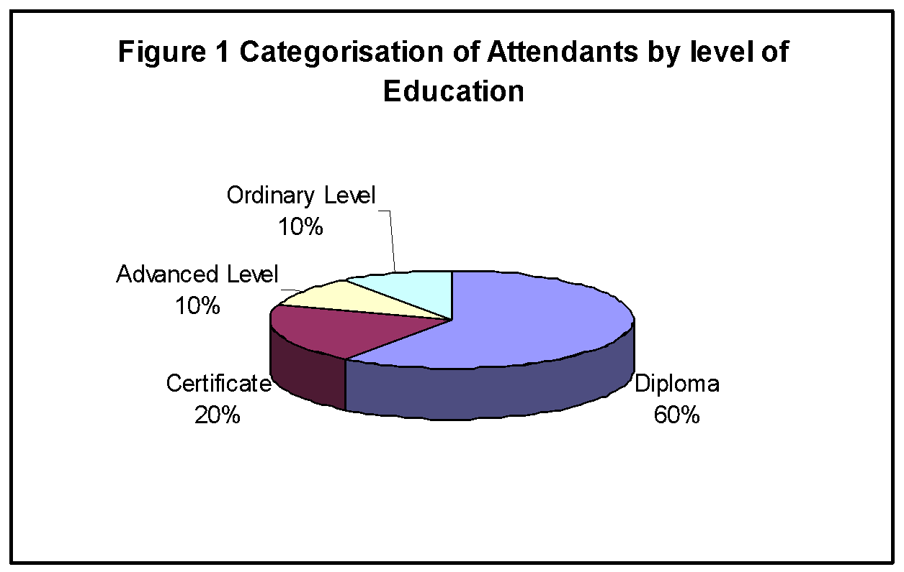
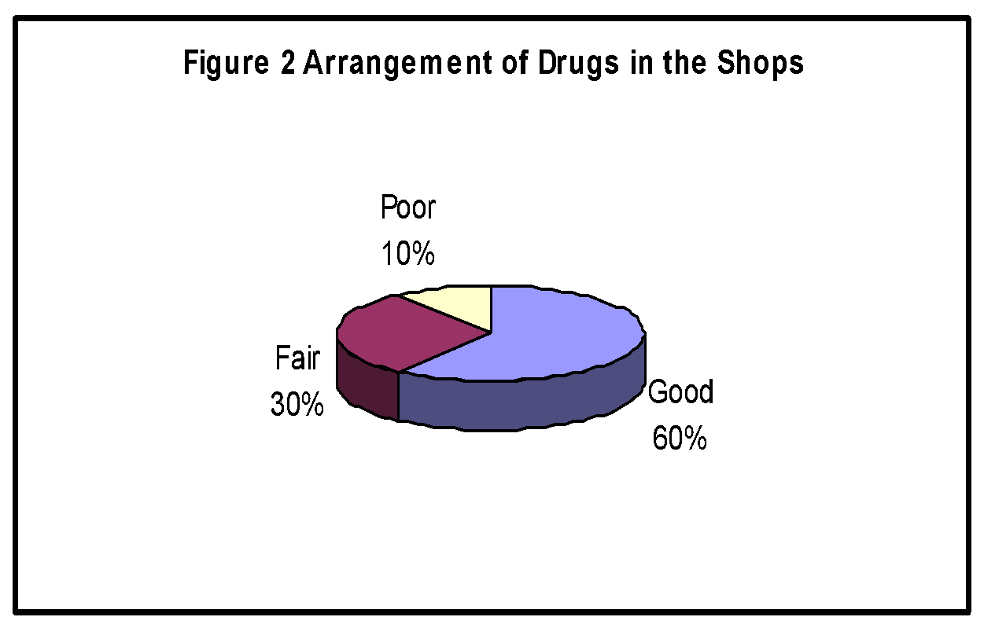

The study showed that the main criteria used for dispensing included history only (60%), desire of the farmer (20%) or both (20%). Drugs were identified only by the trade name without considering the generic name. Drugs dispensed were not labeled, leaving farmers to read for themselves the details for dosage, withdrawal period and other such vital information. Sixty percent of the attendants gave verbal direction for the use of the drugs dispensed, while 40% did not, leaving the farmer to find out the required information from the manufacturer’s instruction for use. Of the farmers interviewed, 86.7% received advice for drug use from the attendants, while 13.3% did not. Up to 59% of farmers indicated that they received information on contraindication of drugs dispensed, while 41% did not.
All drug shops visited had records of drug purchases, sales and the corresponding prices, a basic bookkeeping practice for any business. However, this practice appeared to be driven more by the incentive to maximize profit rather than to facilitate management. One notable exception was the record of visits by the inspectors. The frequency of drug sshops by drug inspectors were as shown in Figure 3. The highest proportion of attendants (40%) reported that inspectors rarely visit their premises (less than one a year), this proportion fell to 30% for those who reported yearly visits, then to 20% for those visited quarterly and finally to 10% for those visited once a month. These finding suggestrd that the rigour of inspection was less than what was required to tightly monitor distribution of veterinary drugs.
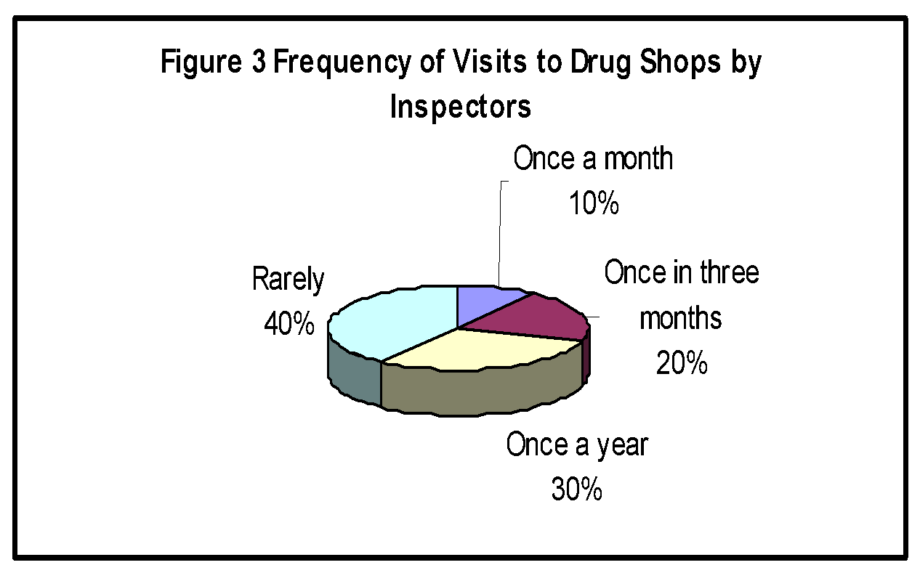
Discussion

According to Desmond, dispensing of veterinary drugs must be entrusted to technically qualified people (9). The findings of this study, according to Martin suggested the possibility of wide spread abuse of veterinary drugs due to inadequate technical expertise of personnel employed to dispense drugs (15). Both Diploma and Certificate holders lack specialized training in dispensing of veterinary preparations. The fact that school leavers attending to the shops were employed by technically qualified veterinarians as part of the family businesses further weakens any professional supervisory responsibilities that the shop owners could impose. Furthermore, the exclusion of primary leavers and those with no formal education implied that stakeholders apparently appreciated the technical nature of veterinary drug dispensing and could therefore be willing to invest in targeted training to improve competence of their employees. These finding exposed the personnel gaps that needed to be filled with specialized training of professionals in drug distribution chain management to minimize wide veterinary spread drug abuse. A case in point was the sale of unpermitted class B drugs which was an indication of inability or unwillingness of NDA to crack down on the distributors, thus endangering animal and human health. According to Lafrana (16), veterinary prescription of drugs such as those of class B should be dispensed on the order of a licensed veterinarian in the presence of valid veterinarian-client relationship. By definition, veterinarian prescribes drugs which by regulation can only be issued by or on order of a licensed veterinarian since adequate directions for their use cannot be written by a lay man (9). This is because they are practically potent or otherwise hazardous having a low range of tolerance in terms of safety of their use.
This location of drug shops in permanent structures appears to be determined by the National Drug Authority regulation that it was precondition for issuance of the license certificate (6). The low status of general hygiene found was a matter for concern as, according to Aulton(13), it could encourage infestation by insects, termites, vermin, rodents or other bird or animals, thus contaminating pharmaceutical products. Fortunately, incidence of dust, which inevitably increases microbial contamination risk (13) was low. Drug packaging was mostly arranged so that identification labels, expiry dates and manufacturing dates were visible. This agreed with deliver’s guidelines for proper storage of health commodities (14) which indicated that cartons should be arranged so that arrow point up and identification labels, expiry dates and manufacturing dates were visible. This could as well be adopted for proper management of animal medicines in drug shops. Water could be associated with increased moisture in drug shops, predisposing drugs to physical changes such as hydrolysis and effervescence or even act a carrier for contaminants(13), it was absolutely necessary for routine cleaning of the shop including mopping the floor so as to avoid contamination from dust associated microorganisms. It was also necessary to reduce injury in cases of accidental contact with some poisonous drugs such as carbon tetrachloride.
The fact that case history was used as the major criterion for dispensing could be attributed to the fact that most attendants received formal education and with experience could reach tentative diagnosis based on the farmers story. There were few dispensed drugs based on the farmers’ desire only reflected the substantial proportion of non-professional personnel with little knowledge in animal diseases. The few attendants who integrated case history and customer desire probably aimed at satisfying farmer’s interests as their primary goal. The appraisal by respondent farmers that attendants gave advice on drug to buy was important because farmers usually had little knowledge on animal diseases and modes of treatment. Mackinon (18) stated that farmers seemed to know the price of everything but had no aspects of value of use of certain drygs. Therefore it wass necessary to discuss the benefits of each approach of treatment in detail. It was important to ensure that treatment was cost effective. The use of brand names rather than generic names in dispensing drugs could be attributed to the easiness to memorize and pronounce brand names. . Not labeling drugs up on dispensing was attributed to most veterinary products being supplied in authorized containers and labeled with warning and contraindications, dosage instructions, batch number and expiry date of the product. However, there were many instances where injectables were dispensed into syringes or unauthorized bottles and tablets into unlabeled paper. This of course disregarded the law in place (6). The Veterinary medicines Directorate of the United Kingdom (17) also advised that where a product was supplied in unauthorized container for example a small number of tablets dispensed from a larger container into a separate bottle, registered qualified persons must ensure that sufficient information was provided on the label to enable the product to be used safely. This practice minimized possible abuse of the drug. All the drug shops surveyed kept records which included; date, drug sold and its price. Record keeping was a good management practice.
While the keeping of records was a good practice in business, it should include as much information as possible and not be limited to purchases, sales and prices. New veterinary drugs and pharmaceuticals appeared in the market from time to time, with new brand names, dispensing guidelines, dosages and contraindication and need to be included in drug business records (19). Also the stock flow, a major determinant of business decisions needed to be captured in drug business records (19).
In conclusion, management status of veterinary drugs in retail drug shops as evidence from Soroti Municipality was poor. The hygienic standard was generally inadequate; sale of unpermitted class of drugs, use of unauthorized containers without labels by untrained attendants was still rampant. This called for more vigilance on the part of the National Drug Authority, District and municipal drug inspectors to ensure compliance with set standards. Furthermore, this study identified that a specialized professional training was needed on veterinary drug chain management so as reduce risks to humans and animals associated with wide spread drug abuse.
References
- Nyeko, J.H.P., Obwoya, E. 1993. Pesticide use in livestock production. Proceedings of the Uganda National Symposium on Pesticide Network (UNSPIN) p 22.
- Hill, L. 1995. New rules on medicines. Vet. Rec.,136:227-228
- Lawrence, D.R., Bennet, P.N. 1992. Clinical pharmacology, 5th edition. Churchhill Livingstone, p 84-93.
- Dunlop, D. 1969. Drugs: their uses and abuses and the problem of their control. Vet. Rec., 85(16):424-429.
- Huber 1976. Impacts of drug legislation. Veterinary pharmaceuticals and therapeutics, 5th edition. Iowa state university press, p 12.
- National Drug Policy and Authority Act 1993. Rules and regulations of handling drugs in Uganda. Republic of Uganda. Uganda Law Reform Commission.
- Cannavan, A.S. 2004.Veterinary drug use and control in developing countries. Joint FAO/WHO technical workshop on residues of veterinary drugs. Available at www.fao.org.docrel/008/Y5723e/eorg.htm. (Date accessed 02/2/2012)
- Niyongira, E., Byekwaso, F. 1976. Farmers views on pesticide use in Agriculture. Proceedings of the Uganda National Symposium on Pesticide Network, UNSPIN, pg 73
- Desmond, H. 1984. Distribution of animal health products by veterinary practices. Vet. Rec.,114:56-65
- Soroti Municipal Council (2009).Soroti Municipal Council HIV/AIDS workplace Policy. Alliance of Mayors and Municipal leaders on HIV/AIDS in Africa.
www.amicaall.org/ug/.../Soroti%20Workplace%20Policy.pdf (Accessed on 02/2/2012).
- Anonymous 1997. Soroti District State of Environment Report. Ministry of Water and Environment, Republic of Uganda.
www.unep.org/Pearl/Login/.../PEARLFullTextBLOB_1543_647.pdf(Accessed on 02/2/2012)
- Tothill, J.D. 1940. Agriculture in Uganda. Oxford: Oxford University Press.
- Aulton, M.E. 2002. Pharmaceutics: The science of dosage form design, 2nd edition. Churchhill Livingstone, pp 556-557.
- Nersesian, P. 2001. Deliver’s guidelines for proper storage of health commodities. Available at www.essential.drugs.org/edrug/archieve/200108/msg00095.php.(Accessed on 02/2/2012)
- Martin, S.W., Meek, A.H., Willeberg, P. 1998. Sampling methods. Veterinary Epidemiology. Principles and Methods, 2nd edition. Iowa State University Press, pp 32-33.
- LaFrana, J. (1993). Principles of veterinary medical ethics: Opinions and reports of the judicial council (1990 revision). In: Caring for Animals (1993). AVMA Directory. Am. Vet. Med. Assoc., Schaumburg, IL. 43–47.
- Veterinary Medicines Directorate (2006). Code of practice. VMD, UK. www.vmd.gov.uk
- Mackinon, J.D. (1992). Drug use and abuse. Iatrogenics or Farmogenics. Pig. Vet. J. 29:148-159.
- Department of Agriculture and Rural Development 2011.Veterinary Medicine Records. DARD, UK.www.dardni.gov.uk. (Accessed on 02/2/2012).

