
Surveys of animal trypanosomosis in Anambra and Delta States of Nigeria

Africa Journal of Animal and Biomedical Sciences 7(1), 2012
ISSN: 1819-4214
©INABSTA

F. N.C. Enwezor¹*, B.O. Ideh² and I. Ikemefuna³
¹ Nigerian Institute for Trypanosomosis and Onchocerciasis Research (N.I.T.O.R), P. M. B. 2077, Kaduna, Kaduna State, Nigeria
² Anambra State Ministry of Agriculture, Veterinary Services, Awka, Anambra State, Nigeria
³Delta State Ministry of Agriculture, Veterinary Services, Asaba, Delta State, Nigeria

*Correspondence: feliciaenwezor@yahoo.com
Abstract

The prevalence of trypanosomes was investigated in animals in the rain forest zone of Anambra and Delta States of Nigeria. Buffy coat method and Giemsa stained thin film were used to diagnose and identify trypanosome species in blood of 357 white Fulani zebu cattle, 70 dogs and 35 pigs collected at random from the study areas. Packed cell volume (PCV) was determined. Structured questionnaire was used to determine the knowledge, attitude and perception (KAP) of herdsmen about trypanosomosis. Results overall showed that 11 (3.08%) cattle, 0 (0 %) dogs and one (2.86%) pig were respectively found infected with trypanosomes and that Trypanosoma vivax was most prevalent followed by T. congolense and T. brucei. The mean PCV (25 %) for the trypanosome-positive and 28 % for trypanosome-negative cattle were within the normal range (≥ 24 %). The herdsmen interviewed were aware of trypanosomosis, tsetse and mentioned weight loss, weakness, and geophagia as symptoms among others. They maintained that trypanosomosis did not pose a serious threat to livestock development in the region and mentioned ticks as important parasitic infection treatable with anti-parasitic drugs. Introduction of cattle from the northern region into the two states was identified as a major factor in the maintenance and spread of animal trypanosomosis. From our findings and given good nutrition as demonstrated by the abundance of fodder all year round, animals were more likely to withstand the deleterious effects of trypanosomosis. The study suggests strengthening intensive commercial cattle production in conjunction with good management practices to help boost cattle development in the region.

Keywords: Prevalence, trypanosomes, cattle, dogs, pigs, Nigeria

Introduction

Tsetse-transmitted African trypanosomosis, a disease of humans and animals caused by several species of trypanosomes is a major constraint to animal production in 37 countries within the sub-Saharan region. An estimated 45-50 million cattle are at risk of infection in the region with an estimated economic loss of up to US$ 1.3 billion in cattle production (1, 2, 3). The disease in animals is caused by T. congolense, T. vivax and T. brucei brucei and symptoms include fever, anaemia, weight loss, listlessness and lymphadenopathy. Effects on reproduction include abortion, premature births, perinatal losses and testicular damage in males (4). Trypanosomes induce immunosuppression. Concurrent infections could hence, complicate the pathology of this disease which outcome may be rapidly fatal if untreated (5, 6, 7).

Trypanosomosis surveillance and control will therefore, help mitigate negative impacts and improve livestock development and consequently animal protein quality and availability. This study was undertaken in a bid to gain a better understanding of the status of animal trypanosomosis in Anambra and Delta States, Nigeria. Here, we report the results of cross-sectional studies that determined the status of trypanosome prevalence in animals in Anambra and Delta States of Nigeria with focus on strategies to adopt to enhance commercial cattle production given the perennial abundant fodder in the areas.

Materials and methods

Anambra State is located at latitude 7º 16’ and 0 seconds north and longitude 7º 0 minutes and 0 seconds east. The State has a population of 4182000 and growing at an annual growth rate of 2.2% (2006 Census). The animal trypanosomosis survey took place in five Local Government Areas (LGAs), namely, Awka North, Awka South, Aguata, Ekwusigo and Njikoka in the month of July 2008. The sixth LGA could not be covered owing to fracas in that area which constrained activity.
Delta State is located at latitude 5º 44’N and 7º 34’ N and longitude 6º 04’N and 6º 43’NIn Delta State, Oshimilli, North and South and Aniocha South LGAs were surveyed in the month of November, 2008. . Details of the study areas were as shown in Fig. 1. In both surveys, ethical clearances were obtained from the relevant States Ministries of Agriculture and Rural development and informed consent from the local Chiefs and Ardos (Fulani Chiefs) and cattle owners to sensitize them in order to obtain consent for animals to be bled.

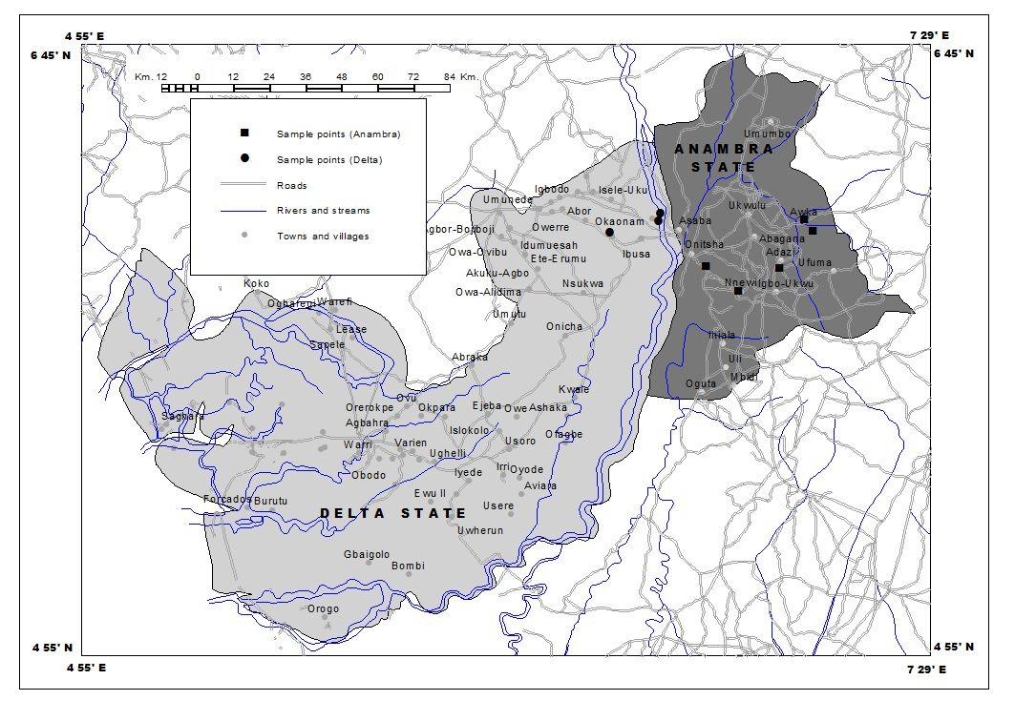
Fig. 1 Map of Anambra and Delta States showing the study areas

Study herds were purposively selected while a systematic random sampling was used to obtain a total of 357 cattle samples. The cattle were drawn as follows: 257 from the five study LGAs in Anambra made up of 80 resident cattle from Isuanaocha farm land in Awka south; 10 trade cattle were sampled at Amanse market, Awka North; 100 resident cattle drawn from six herds were sampled at Ozubulu in Ekwusigo LGA. Seven (7) non resident cattle brought in from Tella, Adamawa State were sampled. At Nimo, Njikoka LGA, 60 resident cattle were also sampled. The 70 dogs and 35 pigs sampled at random were drawn at Ekwuluobia, Aguata LGA as follows: 10 dogs from Nkwo Igbo market, the remaining 60 and 35 pigs were sampled house to house as owners refused to bring their animals to a central place. In Delta, 100 cattle were sampled at random from the three LGAs as follows: 48 cattle from Oshimilli North (30 resident and 18 trade cattle at Commodity market), Ibuzo; 42 resident cattle from Oshimilli South and 10 resident cattle from Ogwashi uku, Anaocha South LGA.

Clinical examination was performed on all animals sampled. A one-page questionnaire was filled for each animal to record biographic information particularly for resident animals. About five milliliters of blood were collected from the jugular vein of each cattle into specimen bottles containing ethylene diamine tetra acetic acid (EDTA) as anti coagulant. For pigs, blood was collected from the clavicle vein and in dogs from the cephalic vein. The samples were examined for parasites using the buffy coat dark ground/phase contrast technique (8) and Giemsa-stained thin smears for trypanosome species identification based on morphology (9). Packed cell volume (PCV) was also determined. Blood drawn from the parasitized pig was inoculated into two rats.

It is worthy of note to mention that not all the areas intended to conduct the study were covered as a result of clash and strife between indigenous and Fulani settlers over ownership of farm/grazing land and crop destruction. The seriousness of the problem ranged from killing of people to cattle rustling. In addition blatant refusals to collect blood samples were met from several herdsmen in both states while some demanded payment to allow sample collection.

Information about knowledge, attitude and practices of the animal owners with regard to awareness of trypanosomosis, tsetse fly and management practices were also obtained. Animals found to be infected with trypanosome parasites were treated with diminazene aceturate at 7.5 mg/kg, intramuscularly. The one infected pig and uninfected ones were penned together and all received quinapyramine sulphate treatment at a combination of quinapyramine dimethyl sulphate at 5mg/kg and diminazene aceturate at 7.5 mg/kg given subcutaneously. The data was analyzed using descriptive statistics (percentage) (10).

Results

On clinical examination, all the cattle, dogs and pigs were in good condition. In the 357 cattle, 70 dogs and 35 pigs sampled, 11 (3.08 %), 0 (0 %) and one (2.86 %) were respectively found to be infected with trypanosomes. Among the positive animals, 6 (54.55 %) were Trypanosoma vivax, 3 (27.27 %) with T. congolense and 2 (18.18%) with T. brucei. The prevalence of infection with T. vivax was significantly higher than with T. congolense or T. brucei (P> 0.005). The mean PCV for the trypanosome-positive animals (25 %) were low compared with the trypanosome-negative animals (28 %) but still within the normal range (≥24).

State by state analysis showed that in Anambra, out of 257 cattle, 70 dogs and 35 pigs sampled, 8 (3.11 %) cattle and 1 (2.85%) pig were diagnosed positive for trypanosomes. All the dogs were found negative (0 %). See Table1 for details. Overall 3.11% cattle 2.85 were trypanosome potistive. No dog was positive.

Table 1: Trypanosome prevalence in Anambra State, Nigeria
Anambra State | No. of Samples | No. Positive | No. Negative | Trypanosome species
Resident cattle | 240 | 5 | 175 | T. vivax (3), T. congolense (2).
Non sresident (newly brought from the north) | 7 | 2 | 5 | T. vivax (1); T. congolense (1)
Trade cattle (from the north) | 10 | 1 | 9 | T. vivax (1)
Resident pig | 35 | 1 | 34 | T. brucei (1)
Resident dogs | 60 | 0 | 60 | -
Trade dogs(local) | 10 | 0 | 10 | -
Total | 302 | 9 | 293

In Delta State, only three (3%) out of 100 cattle investigated were positive for trypanosomes. The positive samples came from trade cattle drawn from the market. All the resident cattle simply referred to as Delta cattle because they were born and bred in Delta State were trypanosome-negative.

Prevalence by LGAs covered were 10 % in Awka north, (Amanse market); 6.25 % in Awka South (Isuanaocha farm land); zero percent respectively in Ekwusigo and Njikoka and 28.5 % infection rate in cattle recently brought in from Tella, Adamawa State and kept separately from other herds sampled at Ekwusigo LGA. In Aguata LGA, 2.9 % and 0 % infection rates were recorded in pigs and dogs respectively. The rats inoculated with the blood from the parasitized pig died within four days before detectable parasitaemia could be established. In Oshimilli North, 6.25 % prevalence was obtained followed by zero prevalence in Oshimilli South and Anaocha South LGAs of Delta State, respectively. Details were as shown in Fig 2.

Table 2: Trypanosome Prevalence in Delta State, Nigeria (2008)
Delta State | No. of Samples | No. Positive | No. Negative | Trypanosome Species
Resident cattle | 40 | 0 | 40 | -
Trade cattle | 60 | 3 | 57 | T. vivax (2), T. brucei (1)
Total | 100 | 3 | 97 | -

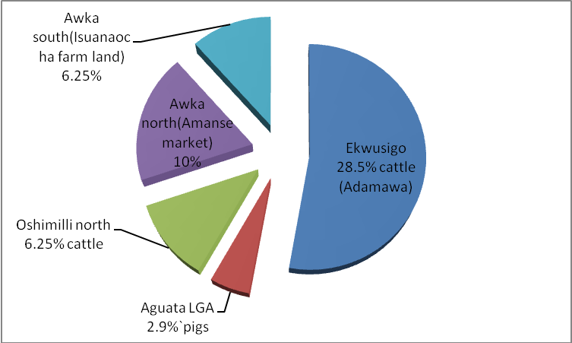

Fig. 2 . Prevalence of Animal Trypanosomosis by LGAs
NB: The LGAs with negative results were not reflected (Ekwusigo, Njikoka, Oshimili south and Anaocha South).

Eighty percent (80%) of the cattle owners said that they were aware of trypanosomosis but that it was not a serious problem in Anambra State compared to the North. They affirmed that trypanosomosis was more rampant with cattle brought in from the north which transfer the disease problem to the ones bred in the state. The respondents at Isuanaocha farm land complained about fly menace which they said disturb a lot in January every year. There is a nearby stream called ‘Umudum’ very close to the farmland. In Ekwusigo LGA, all five respondents interviewed informed that there were biting flies around but that they had embarked on control using pour-on. According to them, this technique of spraying a marketed insecticide on the body of their cattle has helped a lot in maintaining and improving the health status of their cattle. During rainy periods, the pour-on could be repeated every three days. One of the pig owners said that he had lost most of his pigs to illness. He further said that ‘odudu’, Igbo name for tsetse fly could be found in the area. Incidentally one of his pigs was found positive for T. brucei. Similar responses were obtained from the eight cattle owners whose animals were bled in Delta State. They said that animal trypanosomosis so long as it was not transported from the north did not present a serious threat in Delta State in so far as the disease is not transported from the north. For instance, a herd owner claimed that three years ago, cattle brought in from Borno State caused trypanosomosis problem among his herds. The positive samples from Delta State were from trade cattle. The respondents in both States, however, mentioned ticks as important parasitic infection treatable with anti-parasitic drugs.

Discussion

This study has established the status of trypanosome prevalence in the areas surveyed in Anambra and Delta States of Nigeria. The occurrence of animal trypanosomosis in Southern Nigeria had been documented by previous workers, including, Ogunsanmi et al. (11) in Delta State and Wosu and Nwanta (12) and Ezeani et al. (13) in Anambra State. Our results showed more trypanosome infection rates in trade cattle brought in from the north compared with resident cattle and opined that introduction of cattle from the northern region into the two states remains a major factor in the maintenance and spread of animal trypanosomosis in the areas. This view was corroborated by findings from the interviews conducted in which the respondents categorically said that trypanosomosis does not seem to be a problem in the study areas in so far as the disease is not transported into the areas from the north. In the same vein, Wosu and Nwanta (12) stated that animal trypanosomosis is no hindrance to cattle production in the South, given the fact that the affected cattle were more robust, healthier and showed a higher reproductive performance than cattle infected with the disease in Northern Nigeria.

In this study, the mean PCV values obtained for the trypanosome-infected and trypanosome-negative cattle were within the normal reference range (24% and above) indicating that they did not manifest anemia which implied that the cattle were in good condition and apparently in high nutritional status. The anemia in trypanosomosis has been shown to be persistent in the course of the disease which induced anoxic conditions that manifest signs of dysfunction in various organs owing to a fall in tissue pH and vascular damage. The net effect is immune suppression which could complicate the pathology of this disease as a result of predisposition of the hosts to other infections (6, 7 14). It is obvious that resident animals given good nutrition and management practices are more likely to recover rapidly than under nourished and stressed animals (11). Therefore since the zebu breed of cattle resident in the study areas could withstand better trypanosome infections given the green lush pastures in the south region of Nigeria, the study in conjunction with works of others suggests the need to engage in commercial cattle production to boost animal protein availability in the region.
In conclusion, the study showed that trypanosomosis seems not to present a serious problem to livestock production in Anambra and Delta States of Nigeria. In the light of our findings and those of previous workers, the study reiterates strengthening intensive commercial cattle production in conjunction with good management practices in Anambra and Delta States of Nigeria. This will help boost cattle production and enhance animal protein availability in the region.

Acknowledgements

We thank both the then Director General, Professor L. T. Zaria and the Acting Director General, (Dr) A. A. Dangaladima, NITR, Kaduna for funding the study. We gratefully acknowledge Drs. Muogbo, R. Pessu, Okafor, M.A.P., Nwajiani, G.E., Nnoje, C.O.; G. German and Ononiwu, C., for their support and assistance. We wish to express our profound appreciation for the co-operation and excellent technical assistance rendered by Mr. Francis Doro. Finally, we thank the Ardo, Alhaji Jae Arod Goma, Sarkin Fulanis’ of the two States and cattle owners and traders for their interest and co-operation in the study.

References
- F.A.O. 2002. Food, Agriculture and food security: The global dimension. WFS02/TYech/Advance/ Unedited Version, FAO, Rome pp 19-28.
- F.A.O. 2004. The State of Food Insecurity in the World (SOFI) (2004-FAO 2009),
- Thumbi, S. M., Jung, J. O., Mosi, R. O., McOdimba, F. A. 2010. Spatial distribution of African animal trypanosomosis in Suba and Teso districts in Western Kenya. Bio Medical Central Research Notes, 3:6 (http// creative commons.org/ (licenses/by/2.0)/ 1756-0500/3/6.
- CPSPH 2009. Center for Food Security and Public Health. African Animal trypanosomosis, nagana, tsetse disease.
- Whitelaw, D.D., Scott, J.M., Reid, H.W., Holmes, P.H, Jennings, F.W., Uquhart, G.M. 1979. Immunosuppression in bovine trypanosomosis: studies with louping III vaccine. Res. Vet. Sci., 26: 102-106
- Anene, B.M., Chukwu, C.C., Anika, S.M. 1989. Immunosuppression of humoral immune response in canine trypanosomosis. Micro. Lettr, 40: 37- 46.
- Enwezor, F.N.C., Ekejindu, G.O.C. 1998. Suppression of antibody response to sheep red blood cells in murine trypanosomosis. B. Lettr.,57: 175- 181
- Murray, M., Murray, P.K., McIntyre, W.I.M. 1977. An improved parasitological technique for the diagnosis of African trypanosomosis. Tran. R. Soc. Trop. Med. Hyg., 71: 325-326
- Baker, F.J., Silverton, R.E, Pallister, C.J. 2001. Introduction to Medical Laboratory Technology, 7 ed. Arnold, Bounty Press Limited.
- Armitage, P. 1980. Statistical Methods in Medical Research, 5th ed. Blackwell Scientific Publications, Oxford/ London/ Edinburgh/ Briston/Melbourne
- Ogunsanmi, A. O., Ikede, B.O., Akpavie, S. O. 2000. Effects of management, season, vegetation zone and breed on the prevalence of bovine trypanosomosis in Southwestern Nigeria. I. J. Vet Med., 55(2):54-61.
- Wosu, L. O., Nwanta, J. A. 1992. Incidence of trypanosomes and productivity of settled Fulani cattle in Anambra State, Southern Nigeria. Beitr Trop Land. Vet., 30(2): 193-197.
- Ezeani, M.C., Okoro, H., Anosa, V. O. Onyenekwe, C. C., Meludu, S. C., Dioka, C. E., Azikiwe, C. C. 2008. Immunodiagnosis of bovine trypanosomosis in Anmbra and Imo States, Nigeria, using ELISA: Zoonotic implications to human health. J. Vec. B. Dis., 45(4): 292-300.
- Enwezor, F.N.C., Sackey, A.K.B. 2005. Camel trypanosomosis – A review. Vet. Arh., 75(5): 425- 429

