

Africa Journal of Animal and Biomedical Sciences 7(1), 2012
ISSN: 1819-4214
©INABSTA

Evaluation of fish gills as potential target organ for accumulation of heavy metals
O.A. Fakankun, J.O. Babayemi *, S.O. Akosile
Department of Chemical Sciences, Bells University of Technology, Ota.
*Corresponding author: babayemola@yahoo.co.uk
Phone: +2348060709930

Abstract
Fish gills were evaluated in this study as potential target organ for accumulation of heavy metals. Pollution has become a hydra-headed problem which is aggravated daily especially in the developing countries where effective waste management and pollution control are hardly established. In the aquatic environment, several objects, both living and non-living have been studied for use as indicators of water pollution. Two species of fish, tilapia (Tilapia zilli) and cat fish (Chrysichthys nigrodigatatus ), were studied for heavy metal levels in the gills and the fillet. Samples were taken from Ikorodu lagoon in Lagos state, Nigeria. The samples were oven-dried, digested and analyzed using atomic absorption spectrophotometer. The values of heavy metals in the gills of cat fish ranged from 1.08-2.2 mg/kg for Zn; 1.19-2.66 mg/kg, Cu; 5.105-10.56 mg/kg, Pb; ND-10.715 mg/kg, Fe; and 0.66-1.67 mg/kg, Cd. The levels obtained in the fillet of cat fish were 0.787-1.045 mg/kg for Zn; 0.312-1.045 mg/kg, Cu; ND-3.22 mg/kg, Pb; ND-20.102 mg/kg, Fe; and ND-0.777 mg/kg, Cd. For heavy metal levels in tilapia samples, the levels in gills ranged from 1.135-4.07 mg/kg for Zn; 1.11-2.66 mg/kg, Cu; ND-2.102 mg/kg, Pb; 69.105-122.28 mg/kg, Fe; and ND-1.52 mg/kg, Cd. The levels in the fillet of tilapia fish were 0.735-1.585 mg/kg, Zn; 0.752-2.697 mg/kg, Cu; ND-0.392 mg/kg, Pb; 19.572-125.217 mg/kg, Fe; and ND-0.947 mg/kg, Cd. The gill/fillet heavy metal accumulation ratios were all greater than 1, except for Fe in catfish and Cd in tilapia. It could be inferred from this study and the reviewed literatures that fish gill was a potential target organ for accumulation of heavy metals. And this could be due to constant contact of gill blood stream with heavy metal polluted water in the process of inflow and outflow of water through the gills.

Keywords: Fish gill, fish fillet, tilapia, cat fish, heavy metals, target organ

Introduction

Several studies have indicated heavy metal pollution of water bodies arising from anthropogenic sources (1, 2, 3) and the potential risk implications (4). Sekhar et al. (5) recorded concentrations of Zn, Cu, Cd, Pb, Cr, Ni and Co in sediments from Kolleru lake in India, at levels greater than the recommended. While Zn, Cd and Cu showed greater bioaccumulation in fish. Nielsen et al (6) assessed Hg, Pb, Cd and Se in blood from pilot whales caught at the Faroe Islands and in blood from four sperm whales stranded in Denmark. The levels up to 229µg/L Hg in pilot whales, and 2421 and 31100µg/L for Hg and Cd respectively were observed in sperm whales.

Bio-monitoring of heavy metals in the environment have been found useful in giving clue to the sources, routes of exposure and fates of heavy metals in the biosphere. Among the various environmental media, water is of high significance to humans. However, it has proved to be one of the common routes of exposure of toxic materials to humans either through directy consumption of polluted water or consumption of the quatic organisms. Several attempts have been made to make use various aquatic organisms as biomarker of heavy metal pollution in the aquatic ecosystems (7, 8). However, analysis of inappropriate biological tissues could result in making wrong conclusions of the actual status of the pollutants. Tϋrkmen et al. (9) assessed the levels of some heavy metals in fish and found differences in their concentrations in the different tissues analyzed. It became apparent that there was a the need to identify the target organs for chemical pollutants under investigation. Also some previous studies had assessed heavy metal levels in various fish organs (10; 11) but also drew no conclusions which organs were best to monitor for certain heavy metal accumulation. This study therefore aimed at assessing fish gills as potential target organ for accumulation of heavy metals.

Materials and Methods

The species studied were Tilapia zilli and cat fish (Chrysichthys nigrodigatatus). Each fish species were caught at Ikorodu lagoon using drag net, which were usually left overnight in the lagoon by local fishermen. The netted fish were recovered each morning in a picnic box with some quantity of lagoon water transported to the laboratory in Department of Chemical Sciences, Bells University of Technology, Ota. Each fish was properly cleaned by rinsing with distilled water to remove unwanted particles and other substances adhering to the samples. It was then drained under folds of filter, weighed, wrapped in aluminum foil and then frozen at –10^{о}C prior to analysis.

For analysis, the fish samples were defrosted for two or more hours. The scales were removed. The gills were taken fresh and representative portions of the fish fillet were also cut using plastic knife and sterile hand gloves. The samples were dried in the oven at 105ºC. The dried samples were ground to fine particles using porcelain mortar and pestle in the laboratory. One gram of the gills and 2g of the fillet tissue were each weighed into different porcelain crucibles. The samples were ashed in a muffle furnace with gradually increasing temperatures up to 550ºC. Ashing was completed in 2 hrs. The crucibles with the ash were removed and allowed to cool. To each, 5 ml concentrated HCl followed by 5 ml concentrated HNO₃ were added for complete dissolution of the ashes and liberation of the metals into the solution. These were each filtered into 50 ml standard flask and made up to mark with de-ionized water. Analysis for heavy metals was carried out using atomic absorption spectrophotometer, S Series 712354 v1.27 at the wavelengths of 213.9nm (Zn), 228.8nm (Cd), 248.3nm (Fe), 217.0nm (Pb) and 324.8nm (Cu).

Results

Table 1 shows the levels of each metal detected in the gills of cat fish. The values ranged from 1.08-2.2 mg/kg for Zn; 1.19-2.66 mg/kg Cu; 5.105-10.56 mg/kg Pb; ND-10.715 mg/kg Fe; and 0.66-1.67 mg/kg Cd.

The levels of heavy metals obtained in the fillet of cat fish were as presented in Table 2. The ranges were 0.787-1.045 mg/kg for Zn; 0.312-1.045 mg/kg Cu; ND-3.22 mg/kg Pb; ND-20.102 mg/kg, Fe; and ND-0.777 mg/kg, Cd. The levels in gills of tilapia were as shown in Table 3; they ranged from 1.135-4.07 mg/kg for Zn; 1.11-2.66 mg/kg Cu; ND-2.102 mg/kg Pb; 69.105-122.28 mg/kg Fe; and ND-1.52 mg/kg, Cd.

Table 4 shows the levels in the fillet of tilapia fish. The ranges were from 0.735-1.585 mg/kg for Zn; 0.752-2.697 mg/kg Cu; ND-0.392 mg/kg Pb; 19.572-125.217 mg/kg, Fe and ND-0.947 mg/kg Cd. Figures 1-2 show the mean levels in the gills and the fillet from cat fish and tilapia respectively. Figure 3 illustrates the ratio of accumulation of the metals in the gills and the fillet.

Table 1. Levels of heavy metals (mg/kg) in the gills of cat fish (CFG).
Sample | Zn | Cu | Pb | Fe | Cd
CFG1 | 1.84 | 2.09 | 10.56 | 4.01 | 1.67
CFG2 | 1.61 | 2.66 | 5.11 | 10.72 | 0.88
CFG3 | 1.29 | 1.19 | 5.46 | 4.72 | 1.32
CFG4 | 2.2 | 2.35 | 5.88 | 2.97 | 0.66
CFG5 | 1.08 | 2.66 | 5.64 | 0 | 1.14

Table 2: Levels of heavy metals (mg/kg) in the fillet of cat fish (CFF),.
Sample | Zn | Cu | Pb | Fe | Cd
CFF1 | 1.045 | 0.715 | 0 | 15.84 | 0
CFF2 | 0.867 | 0.312 | 1.047 | 0.23 | 0.452
CFF3 | 0.982 | 0.682 | 0 | 0 | 0.777
CFF4 | 0.925 | 0.3975 | 0 | 20.12 | 0
CFF5 | 0.787 | 1.045 | 3.22 | 0 | 0

Table 3. Levels of heavy metals (mg/kg) in the gills of tilapia fish (TFG).
Sample | Zn | Cu | Pb | Fe | Cd
TFG1 | 3.575 | 2.665 | 2.102 | 98.275 | 1.52
TFG2 | 1.135 | 2.05 | 1.000 | 78.105 | 0.125
TFG3 | 2.265 | 1.865 | 0.06 | 80.515 | 0
TFG4 | 4.07 | 2.205 | 0 | 122.28 | 0
TFG5 | 1.685 | 1.11 | 0.06 | 69.105 | 0

Table 4. Levels of heavy metals (mg/kg) in the fillet of tilapia fish (TFF).
Sample | Zn | Cu | Pb | Fe | Cd
TFF1 | 1.585 | 0.752 | 0 | 20.475 | 0
TFF2 | 0.735 | 0.762 | 0 | 30.147 | 0
TFF3 | 1.077 | 0.867 | 0.392 | 25.717 | 0.947
TFF4 | 1.072 | 1.102 | 0.252 | 125.2175 | 0.83
TFF5 | 0.942 | 2.697 | 0 | 19.572 | 0.235

Figure 1: Mean concentrations of heavy metals in CFG and CFF
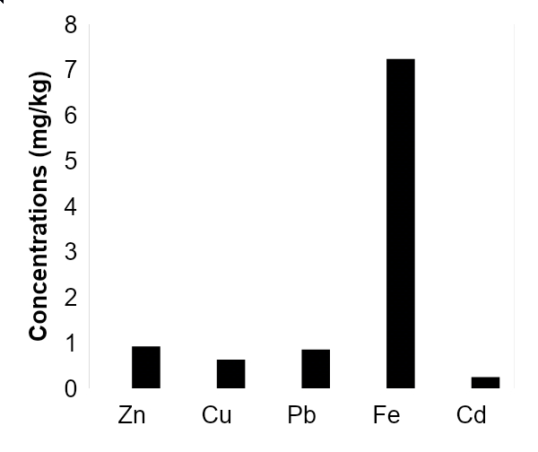
Figure 2: Mean concentrations of heavy metals in TFG and TFF
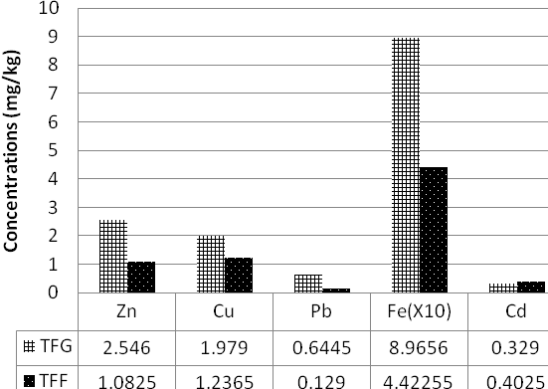

Figure 3: Mean gill/fillet heavy metal accumulation ratio
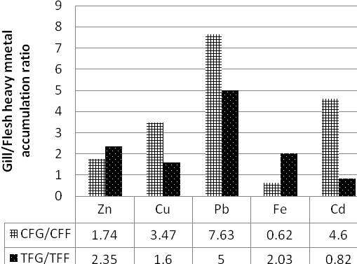

Discussion

The mean levels of Zn were 1.602 and 0.922 mg/kg in cat fish gill and fillet, and 2.546 and 1.083 mg/kg in tilapia fish gill and fillet respectively. These results were similar to those obtained by Olowu et al. (12) for Epe and Badagary lagoons in Lagos, Nigeria. They obtained values of 1.30 and 0.552 mg/kg for gills and fillet of tilapia, and 1.32 and 0.62 mg/kg for cat fish respectively. A slightly higher level in this study could indicate higher level of pollution in the location of study. In this study and in the reference, the levels of Zn were higher in the gills than in the fillet.

The mean levels obtained for Cu in this study were 2.19 and 0.631 mg/kg for catfish gill and fillet, while the mean levels in tilapia were 1.979 and 1.237 for gill and fillet respectively. Karadede and Unlu (13) reported a range of Cu levels of 0.03-7.00 mg/kg for gills and 0.05-4.29 mg/kg for fillet in the analysis of six different species of fish from Turkey. Their findings were comparable to those obtained in this study. The Cu levels here and in the reference for gills were higher than the levels in the fillet.

The mean Pb levels were 6.52 and 0.631 mg/kg in the catfish gill and fillet, and 0.645 and 0.129
in the tilapia fish gill and fillet respectively. These were comparable to a range of 0.40-7.15 mg/kg reported by Tϋrkmen et al. (9) for twelve species of fish studied. It was also be observed here that the Pb levels in the gills were higher than the levels in the fillet.

The Fe levels had means of 4.5 and 7.236 mg/kg in the gill and fillet of catfish, and 89.66 and 44.23 mg/kg in the gill and fillet of tilapia respectively. The levels follow the same trend in tilapia (Fe is higher in the gill than in the fillet); there is a deviation only here in catfish. Significantly higher levels of Fe concentration could indicate severe pollution of the water body under investigation or some mechanism of bio-concentration of Fe in the fish species. Similar higher levels were observed by Türkmen et al (9) giving a range of 9.18-99.0 mg/kg in some species of fish. Mendil and Uluözlϋ (14) observed some levels above 100 mg/kg.

Cd mean levels were 1.132 and 0.246 mg/kg in the gill and fillet of catfish, and 0.329 and 0.403 mg/kg respectively. The gill had higher value than the fillet in catfish; but there is a slight deviation in tilapia. The levels are comparable to those reported by Tϋzen (15).

The gill/fillet heavy metal accumulation ratios (Figure 3) were all greater than 1, except for Fe in catfish and Cd in tilapia.

In conclusion it could be inferred from this study that fish gill was a potential target organ for accumulation of heavy metals. This was could be due to constant contact of gill filaments with polluted water leading to higher absorption rate and accumulation.

References

1. Mendil, D., Uluözlϋ, O.D., Hasdemir, E., Tϋzen, M., Sari, H., Suicmez, M. 2005. Determination of trace metal levels in seven fish species in lakes in Tokat, Turkey. Food Chemistry, 90: 175–179.
2. de Mora, S., Fowler, S.W., Wyse, E., Azemard, S. 2004. Distribution of heavy metals in marine bivalves, fish and coastal sediments in the Gulf and Gulf of Oman. Marine Pollution Bulletin, 49: 410–424.
3. Sankar, T.V., Zynudheen, A.A., Anandan, R., Nair, P.G. V. 2006. Distribution of organochlorine pesticides and heavy metal residues in fish and shellfish from Calicut region, Kerala, India. Chemosphere, 65: 583–590.
4. Castro-Gonzáleza, M.I., Méndez-Armenta, M. 2008. Heavy metals: Implications associated to fish consumption. Environmental Toxicology and Pharmacology, 26: 263–271.
5. Sekhar, K.C., Chary, N.S., Kamala, C.T., Raj, D.S.S., Rao, A.S. 2003. Fractionation studies and bioaccumulation of sediment-bound heavy metals in kolleru lake by edible fish. Environment International, 29: 1001-1008.
6. Nielsen, J.B., Nielsen, F., Jørgenson, P., Grandjean, P. 2000. Toxic metals and selenium in blood from pilot whales (Globicephala melas) and sperm whales (Physeter catodon). Marine Pollution Bulletin, 40 (4): 348-351.
7. Birungi, Z., Masola, B., Zaranyika, M.F., Naigaga, I., Marshall, B. 2007 . Active biomonitoring of trace heavy metals using fish (Oreochromis niloticus) as bioindicator species. The case of Nakivubo wetland along Lake Victoria. Physics and Chemistry of the Earth, 32: 1350–1358.
8. Akan, J.C., Abdulrahman, F.I., Sodipo, O.A., Akandu, P.I. 2009. Bioaccumulation of some heavy metals of six fresh water fishes caught from lake chad in doron buhari, maiduguri, borno state, Nigeria. Journal of Applied Sciences in Environmental Sanitation,, 4(2): 103-114
9. Türkmen, M., Türkmen, A., Tepe, Y., Töre, Y., Ates, A. 2009. Determination of metals in fish species from Aegean and Mediterranean seas. Food Chemistry, 113: 233–237.
10. Dural, M., Göksu, .Z.L., Özak, A.A. 2007. Investigation of heavy metal levels in economically important fish species captured from the Tuzla lagoon. Food Chemistry, 102: 415–421.
11. Mormede, S., Davies, I.M. 2001. Heavy metal concentrations in commercial deep-sea fish from the Rockall Trough. Continental Shelf Research, 21: 899–916.
12. Olowu, R. A., Ayejuyo, O. O., Adewuyi, G. O., Adejoro, I. A., Denloye, A. A. B., Babatunde, A. O., Ogundajo, A. L. 2010. Determination of Heavy Metals in Fish Tissues, Water and Sediment from Epe and Badagry Lagoons, Lagos, Nigeria. E-Journal of Chemistry, 7(1): 215-221. http://www.e-journals.net.
13. Karadede, H., Unlu, E. 2000. Concentrations of some heavy metals in water, sediment and Fish species from the Ataturk Dam Lake (Euphrates), Turkey. Chemosphere, 41: 1371-1376.
14. Mendil, D., Uluözlϋ, O.D. 2007. Determination of trace metal levels in sediment and five fish species from lakes in Tokat, Turkey. Food Chemistry, 101: 739–745.
15. Tüzen, M. 2003. Determination of heavy metals in fish samples of the middle Black Sea (Turkey) by graphite furnace atomic absorption spectrometry. Food Chemistry, 80: 119–123.

